

IN-IT-GUEST HMS

User Guide

Abstract

User guide for the IN-IT-GUEST HMS system

AYANA P DHARMAN

14-08-2020

Table of Contents

Login Screen 3

Process Screen 3

Reservations 4

Reception 11

Requests 15

Reports 17

Shifts 18

Tools 19

HK 29

Setup 30

How to Install 51

# Login Screen

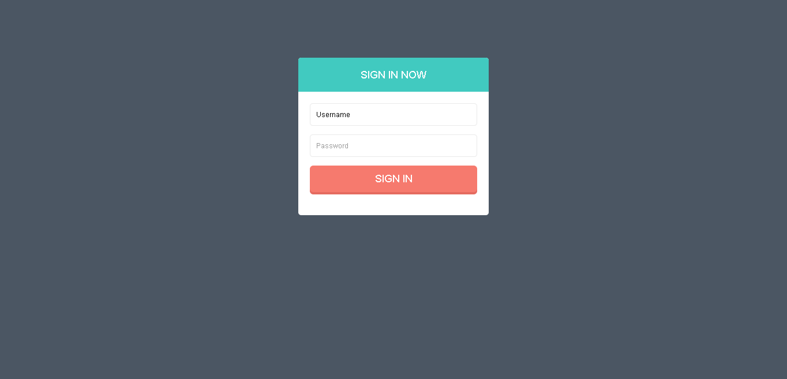

Fig : 1.1

Functionalities

Login screen includes:

1. Username: User can specify the login username.
2. Password: User can specify the login password.

# Process Screen

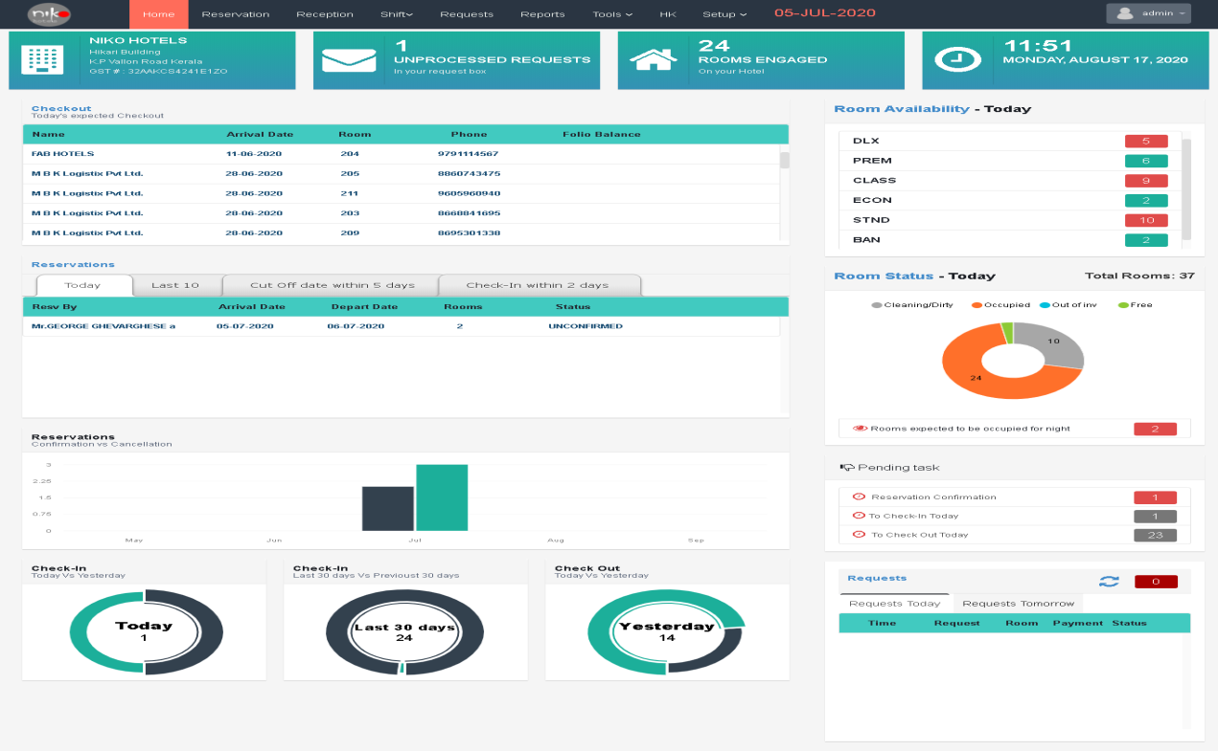

Fig :2.1

Functionalities

After successful login we can see the dashboard of the system. Here we can see the functionalities provided by this system. We can see there a top navigation, checkout list, reservation table, room status, reservation displayed in a bar diagram on the basis of confirmation vs. cancellation, pending task list, requests and pictorial representations of check in and check outs.

1. **Top Navigation**

Top navigation includes home button, reservation button, reception button, request button, reports button, HK button, three dropdowns like shift, tools and setup and the admin block with profile view portion, settings and logout option.

1. **Checkout List**

The check out list is given by the availability of room on the current day.

1. **Reservations**

Reservations table given by the details about the current day reservations, last 10 reservations, cutoff date within 5 days and the check in details within 2 days.

1. **Room status**

Pictorial representation of room status on current day, total number of rooms available gives in number and number of rooms expected to be occupied for night.

1. **Reservations Bar diagram**

Bar diagram gives the details about the reservations on the basis of cancellation Vs Confirmations.

1. **Pending task**

Pending task table gives the pending list of tasks.

1. **Diagram of check in and check out**

Pictorial representations of check in and check out details

1. **Requests**

There are two sections in requests table requests today and tommorrow. When we select the requests today column, today’s requests details will shown in the below table and when we select the request tomorrow column, tomorrow request details will shown.

# Reservations

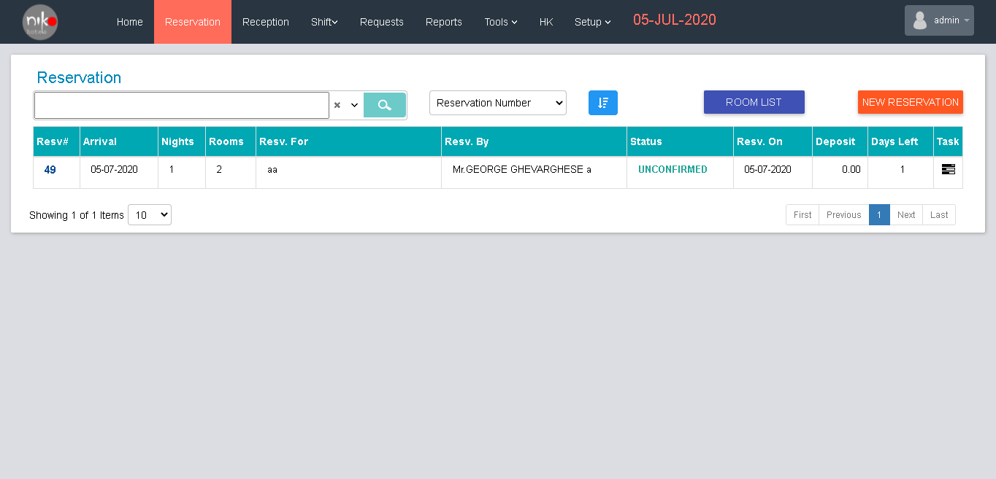

Fig : 3.1

Functionalities

Here the user can manage the Reservations in the hotel. User can search the reservations, filter the reservations, and see the room list, and add new reservations using this screen.

“Room list” button - Navigate to the Room list screen.

‘’New Reservation” button- Navigate to the new reservation entry screen.

When user selects the item from dropdown shown in the screen used to filter the table as per the item.

Search criteria

1. Date
2. Name
3. Number

User can quick filter using this search bar

List Content

|  |  |  |
| --- | --- | --- |
| Sl. No. | Contents | Descriptions |
| 1 | Number | Enter the reference number |
| 2 | Arrival | Arrival date |
| 3 | Night | No. of night stay |
| 4 | Rooms | No. of rooms reserved |
| 5 | Reserved for | The room reserved for whom |
| 6 | Reserved by | Name of the client who reserved the room |
| 7 | Status | Status of the room |
| 8 | Reserved on | Date of reservations |
| 9 | Deposit | Advance payment |
| 10 | Day left | How many days left |
| 11 | Task | List of task assigned |

Table: 3.1

When we click the down arrow seen in the search bar, a form will show as given below.

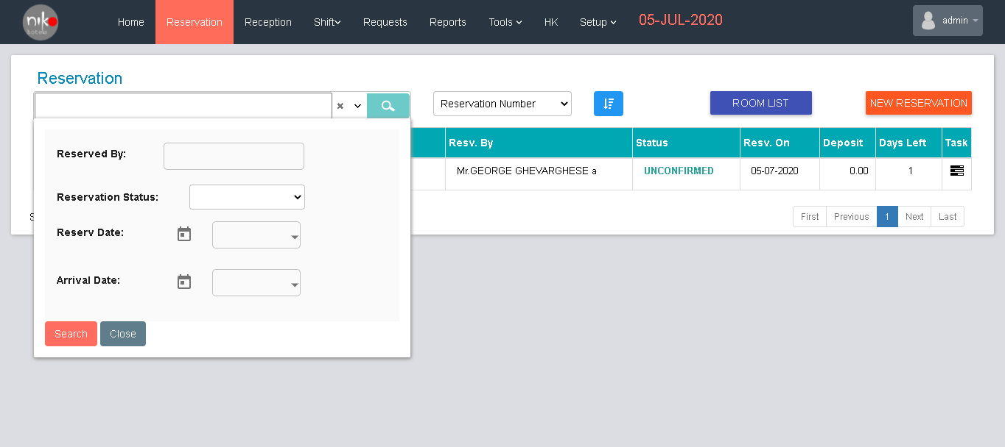

Fig: 3.2

Here we can filter the data’s using this form

1. Reserved By – name of the client who reserved the room.
2. Reservation status – reservation status.
3. Reserved date – date of reservation.
4. Arrival date – date of arrival

Then click search button to filter the details.

When we click the room list button, list screen will show as below.

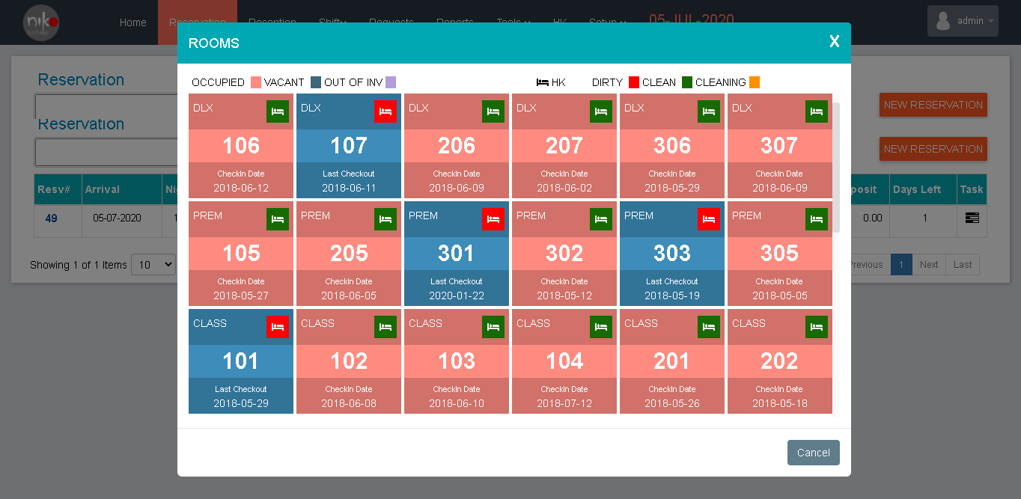

Fig : 3.3

Here user can see the vacant room for the reservations.

Then the user clicks the “New Reservation” button the screen navigate to the registration screen as shown below.

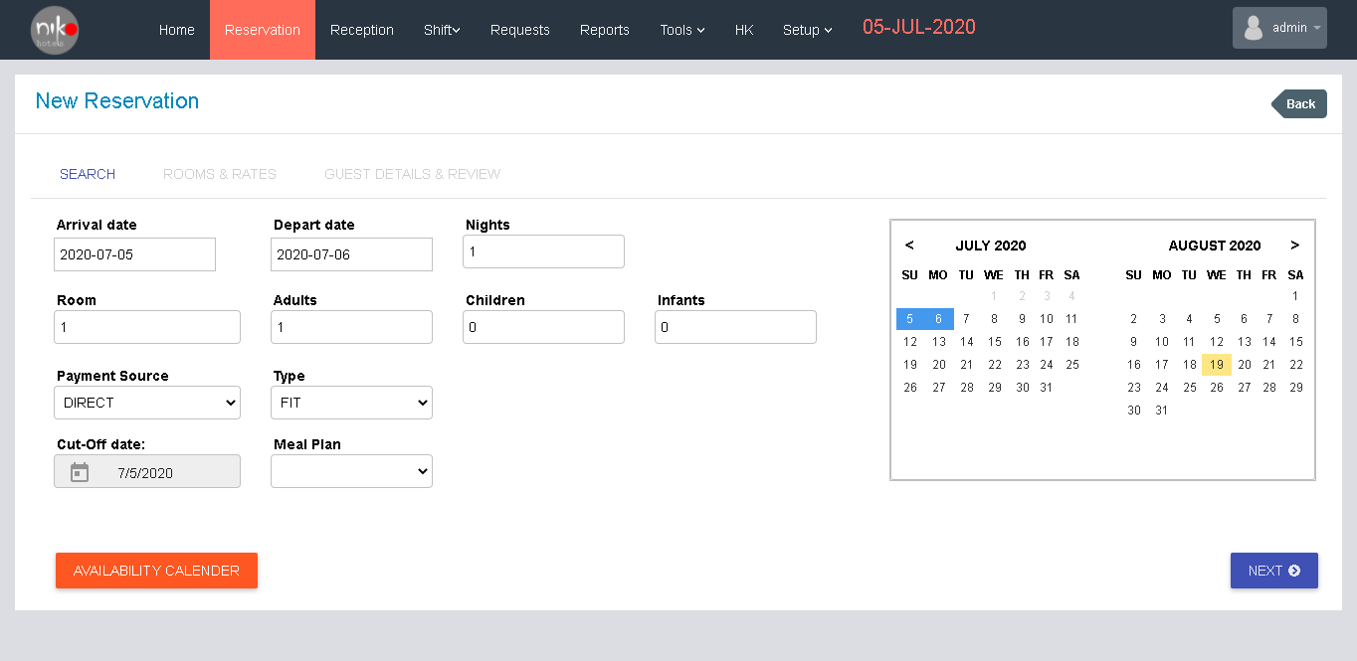

Fig: 3.4

This is the first step of reservation registration. Enter the details correctly

|  |  |  |
| --- | --- | --- |
| Sl. No. | Contents | Description |
| 1 | Arrival | Date of arrival |
| 2 | Depart date | Departure date |
| 3 | Nights | How many nights will stay |
| 4 | Rooms | No. of room needed |
| 5 | Adults | No. of adults |
| 6 | Children | No. of children |
| 7 | Infants | No. of infants |
| 8 | Payment source | Select the method of payment |
| 9 | Type | Select the type |
| 10 | Cut-off date | Select the cut-off date |
| 11 | Meal plan | Select the meal plan from the dropdown |

Table : 3.2

User can see the availability calendar by clicking the button “Availability calendar” in the screen the click the next button for next step of registration. Then a new screen will show as below.

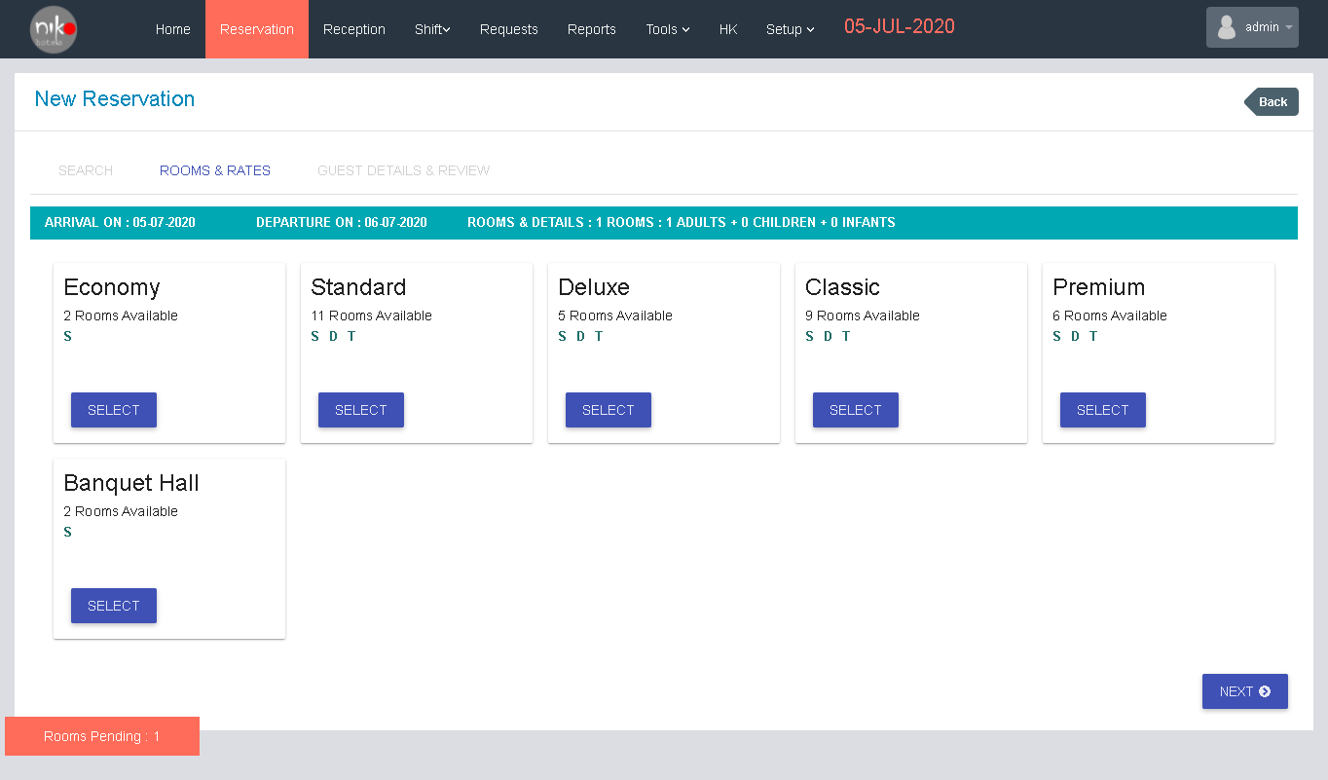

Fig:3.5

This is the next step of registration; here user can see the rooms and their rates.

If the client selects the economy then click the select button then details will popup as shown below.

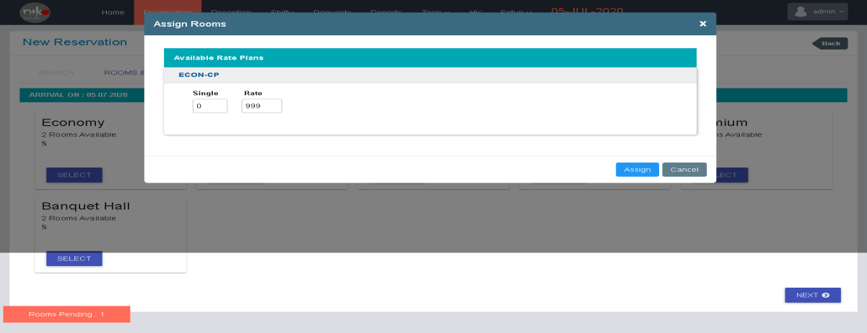

fig: 3.6

Select the no of single needed then the rate will shown in the screen, then click the assign button to assign the room.

If the client wants standard type room, the select the standard type by clicking the select button from the standard type column. Then a screen wills popup as shown below.

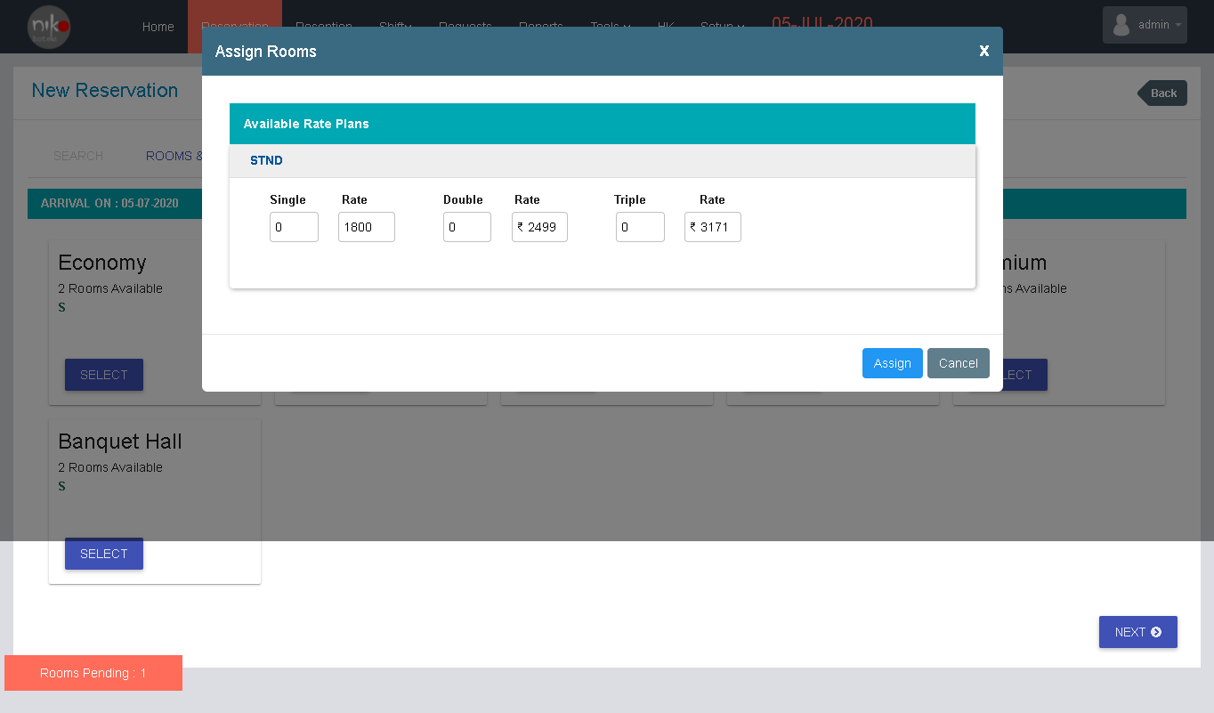

Fig: 3.7

Select the room type as single, double or triple then click the assign button to assign the room.

If the client wants deluxe type room, the select the Deluxe type by clicking the select button from the deluxe type column. Then a screen wills popup as shown below.

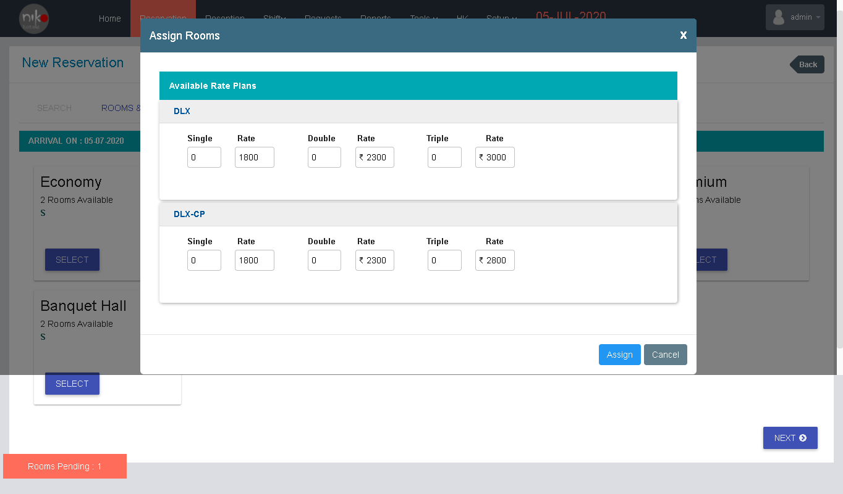

Fig:3.8

Then select the room type and make sure about the rate of every room then click the assign button to assign the room.

If the client wants the classic type room, click the select button from the classic column then a screen will popup as shown below.

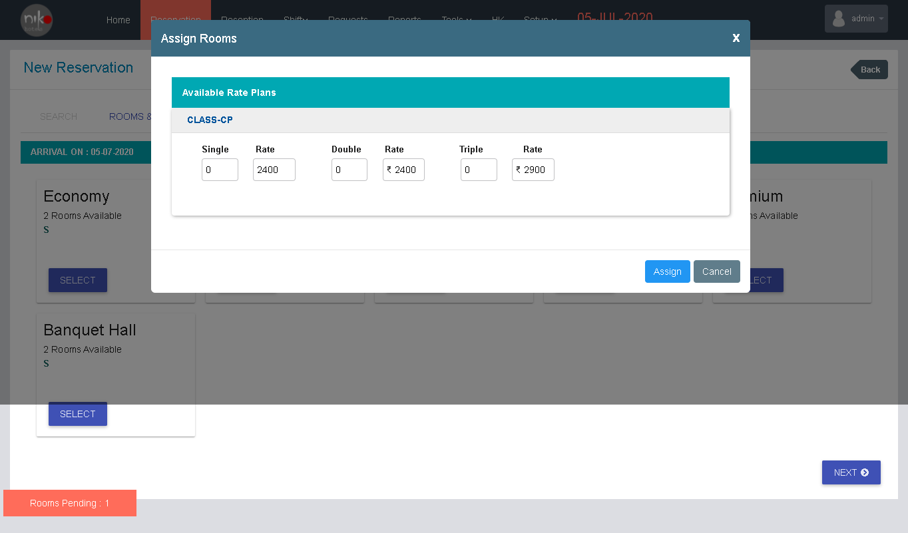

Fig: 3.9

Then select the room type and make sure about the rates then click the assign button to assign the room.

If the client wants the premium type room, click the select button from the premium column, then a screen will shown as below.

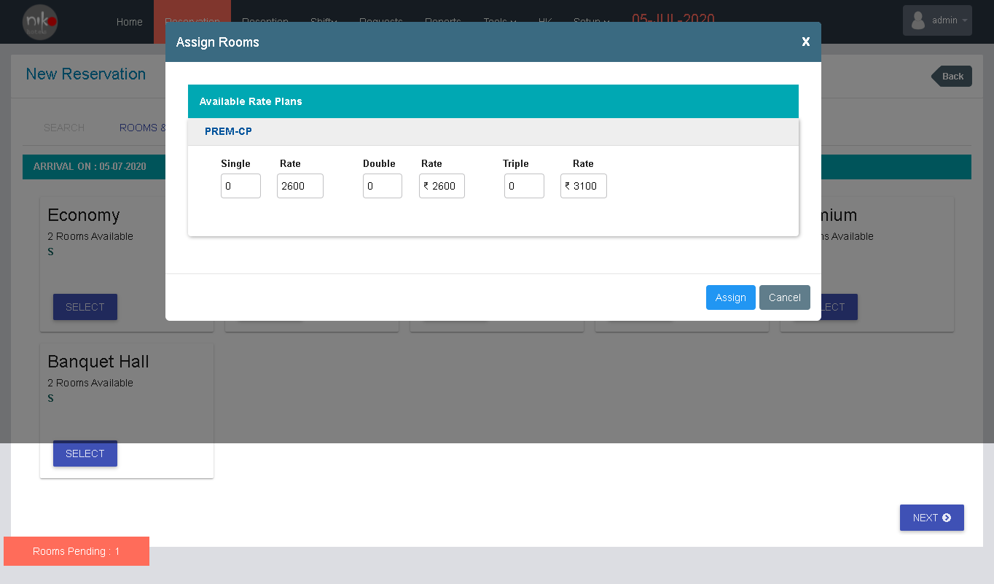

Fig: 3.10

Then select the rooms and make sure about the rates and then click the assign button to assign the room.

If the client wants the banquet hall, then click the select button from the banquet hall column, then a screen will shown as below.

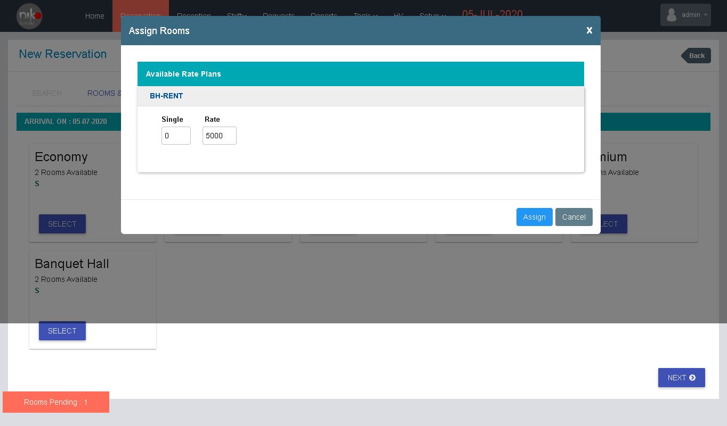

Fig:3.11

Select the room and make sure about the rate of the room and then assign the room by clicking the assign button from the screen.

Then click the next button shown in the screen to complete the next step of the registration. Then a new screen will shown as given below.

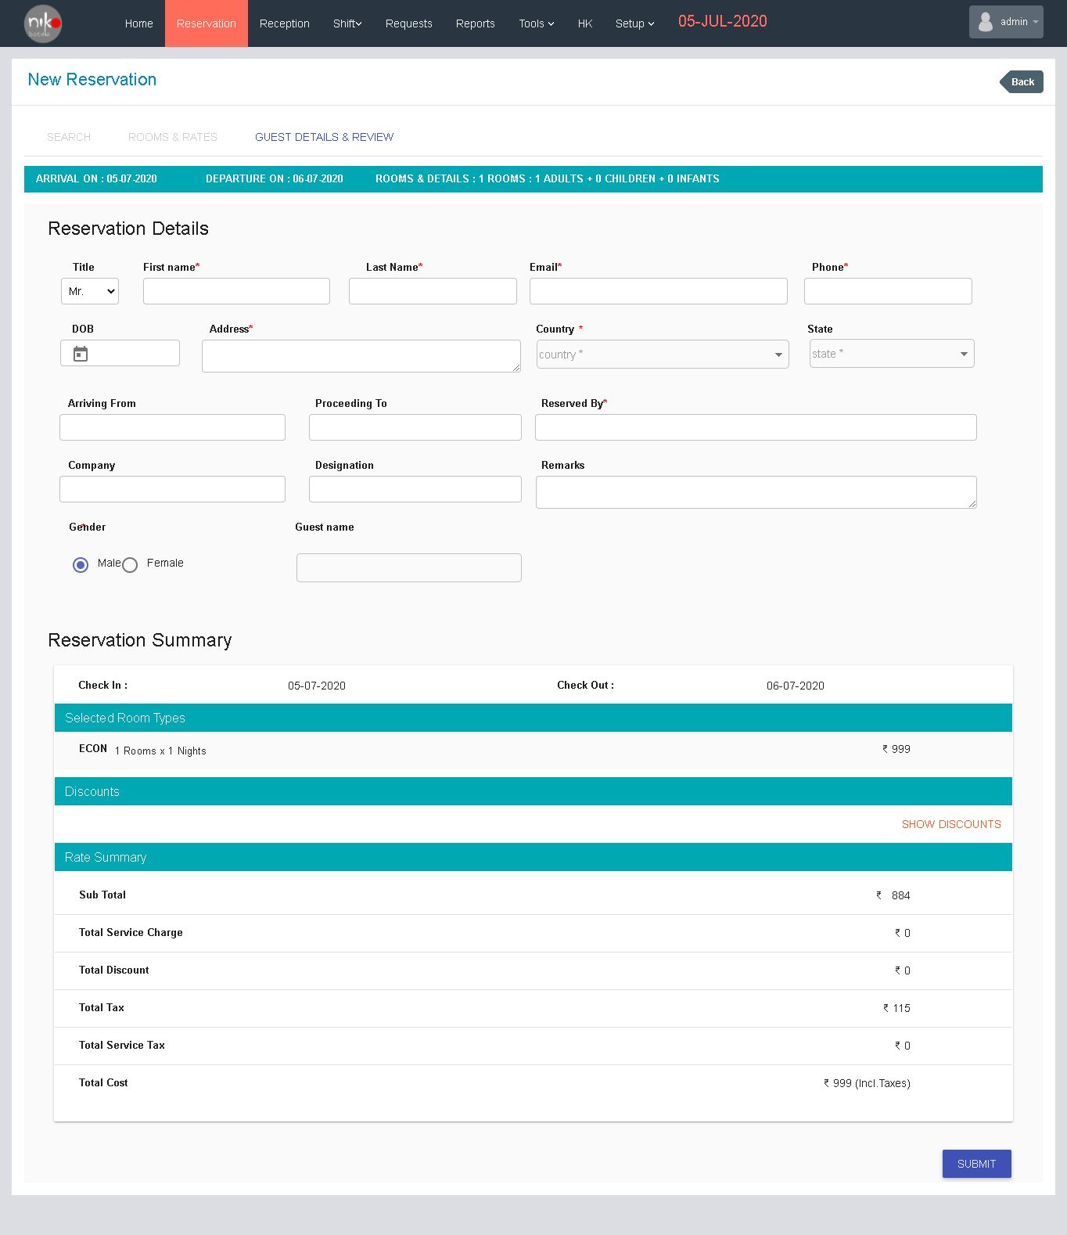

Fig:3.12

The next step is the final step of registration, here user enter the details about the guest and add the reviews in this screen. User can enter the details in the form seen in the screen.

|  |  |
| --- | --- |
| Sl. No. | Contents |
| 1 | Title |
| 2 | First name |
| 3 | Last name |
| 4 | Email |
| 5 | Phone |
| 6 | DOB |
| 7 | Address |
| 8 | Country |
| 9 | State |
| 10 | Arriving from |
| 11 | Proceeding to |
| 12 | Reserved by |
| 13 | Company |
| 14 | Designation |
| 15 | Remarks |
| 16 | Gender |
| 17 | Guest name |

Table 3.3

Enter the details correctly and then user can see the reservation summary and then click the submit button. The new reservation registration is completed after completing these steps.

# Reception

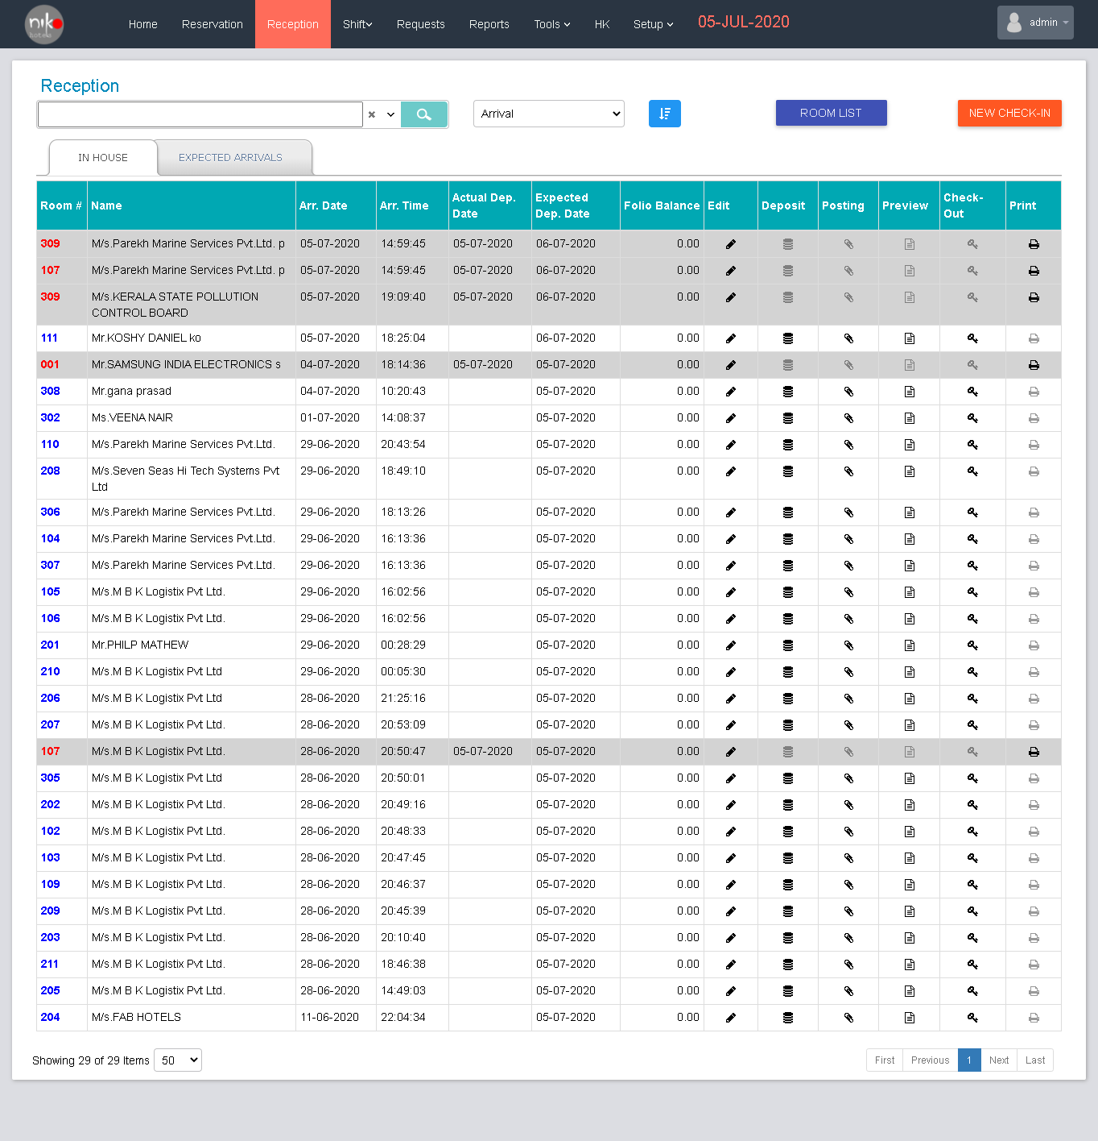

Fig: 4.1

Functionalities

Here the user can manage the Reception section in the hotel. User can search the reception details, filter the reception, and see the room list, and add new check in using this screen.

“Room list” button - Navigate to the Room list screen as same as above section

‘’New Check In” button - Navigate to the new check in entry screen.

When user selects the item from dropdown shown in the screen used to filter the table as per the item.

Search criteria

1. Room Number
2. Customer Name
3. Check Out Date

User can quick filter using this search bar

List Content

List Contents in house section is listed below.

|  |  |
| --- | --- |
| Sl. No. | Contents |
| 1 | Name |
| 2 | Arrived date |
| 3 | Arrived time |
| 4 | Actual Dep. Date |
| 5 | Expected dep. date |
| 6 | Folio balance |
| 7 | Edit |
| 8 | Deposit |
| 9 | Posting |
| 10 | Preview |
| 11 | Check out |
| 12 | Print |

Table :4.1

List in expected arrivals listed below.

1. Arrivals
2. Nights
3. Rooms
4. Resv. For
5. Resv. By
6. Status
7. Resv. On
8. Deposit
9. Task

The tables show the details about the reception. User can view the room list by clicking the room list button on the screen. Then the new check in button navigates the screen to new check in registration screen as shown below.

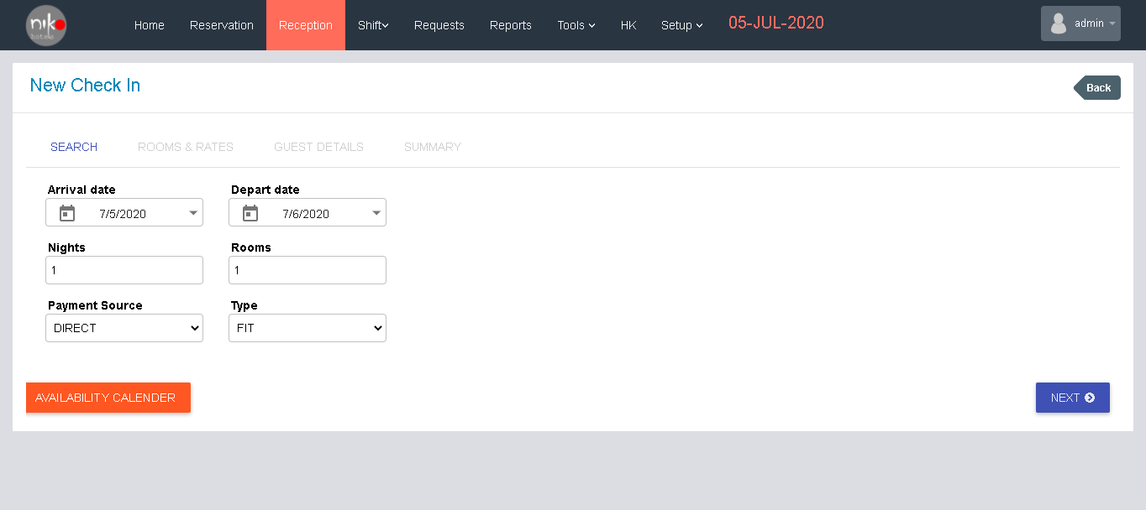

Fig: 4.2

The user enters the details about the arrival date, depart date, no. of nights, and no. of rooms, payment source and type then user can check the availability by clicking the button “availability calendar” then click the next button to complete the registration. Then a room and rate screen will be shown as below.

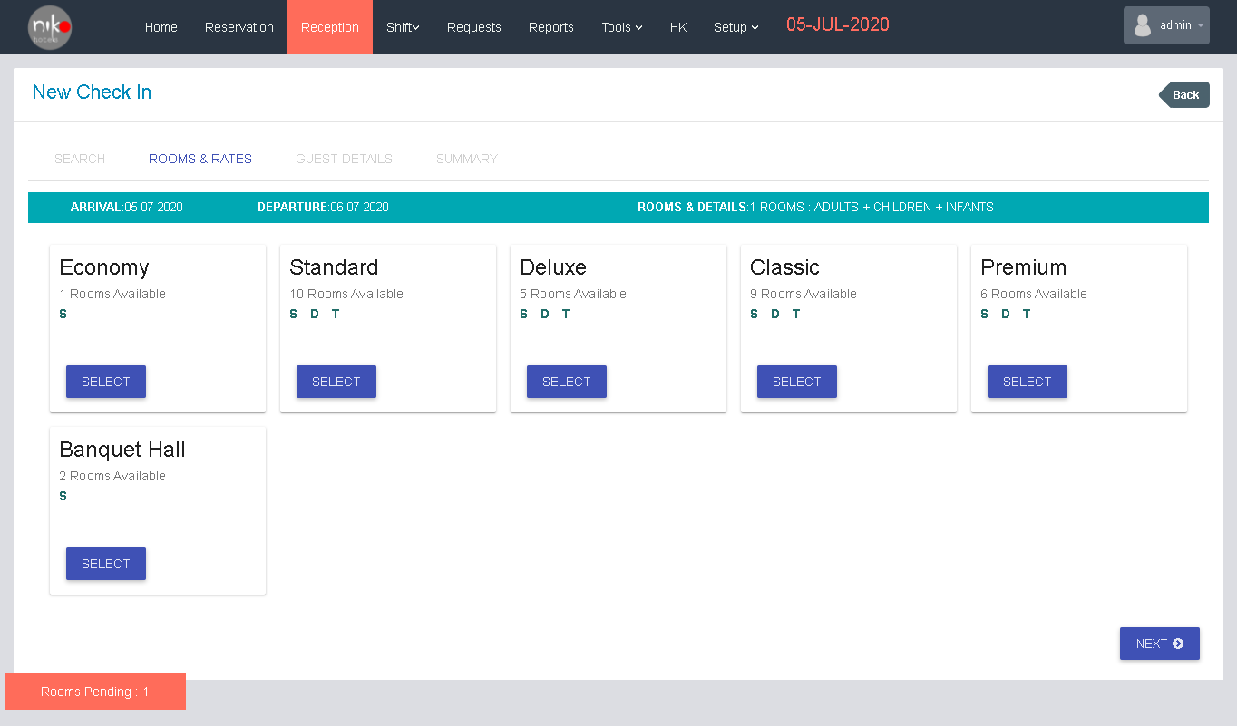

Fig: 4.3

Then user can select the room as same as the room selection in reservation module then click the next button to enter the guest details. Then a new window will show as given below.

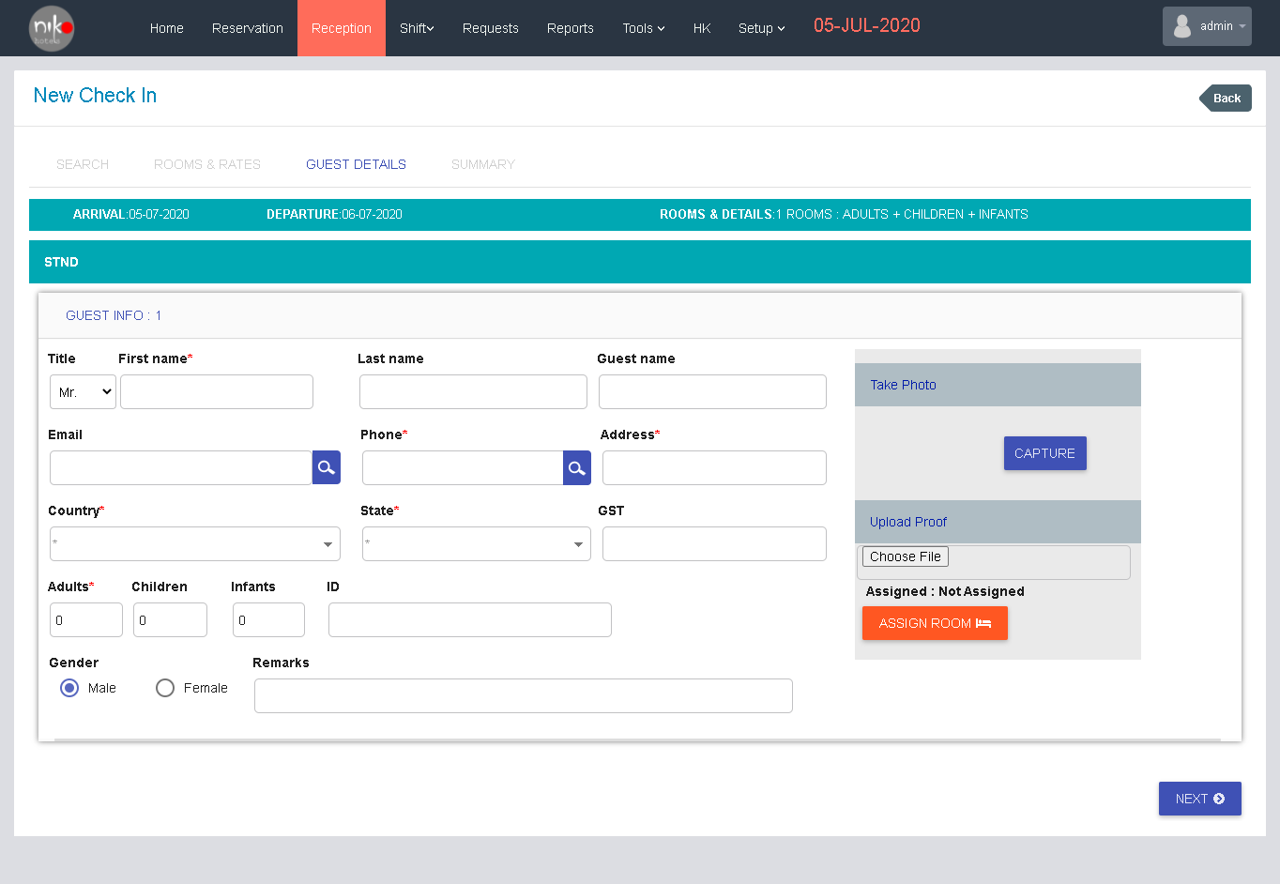

Fig: 4.4

Then user will enter the guest details in the form given in the screen then assign the room by clicking the assign room button shown in the screen. When user click the assign room button a popup will shown as given below.

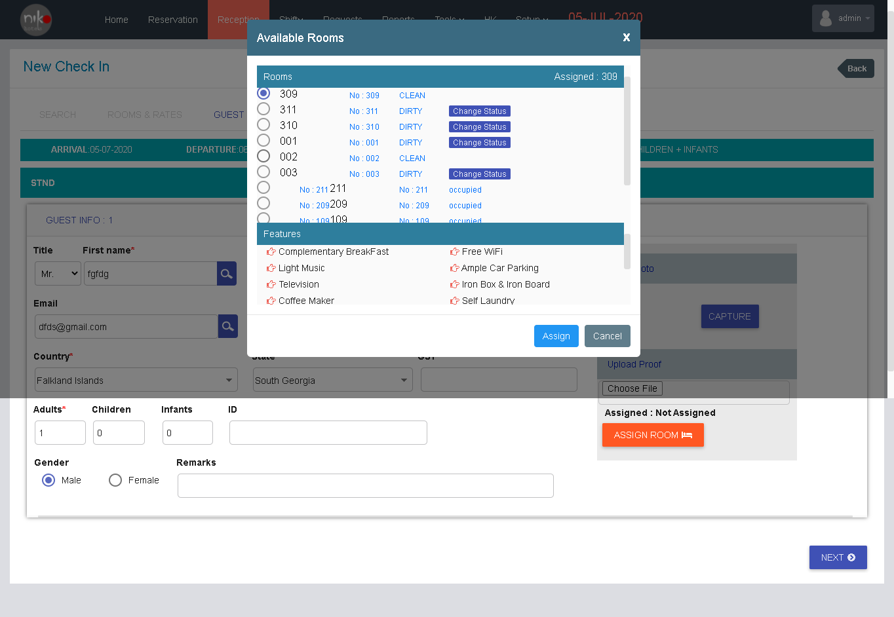

Fig:4.5

Then select the room and click the assign button to the assign the room. Then click the next button to complete the next step of registration. Then a summary screen will be shown as given below.

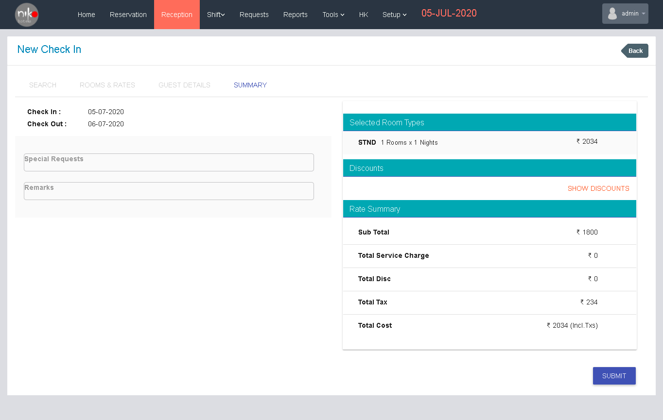

Fig: 4.6

Then the user can see the summary of the registrations then user can check the details then click the submit button to submit the check in.

# Requests

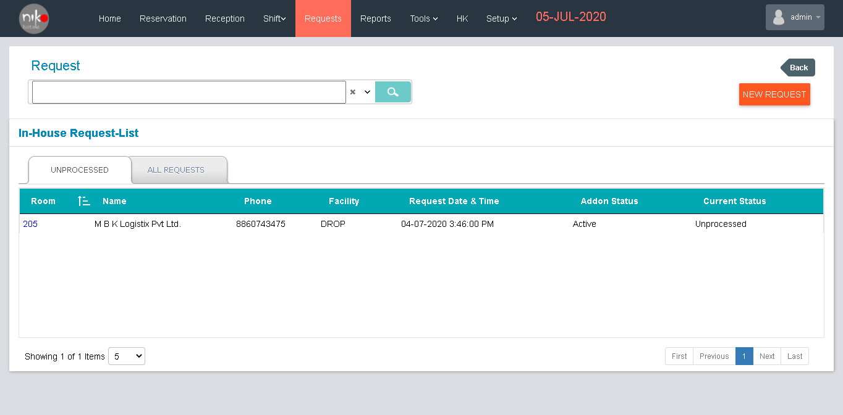

Fig: 5.1

Functionalities

Here the user can manage the Request section in the hotel. User can search the request details, filter the request, and add new request using this screen.

“New Request”: Navigate the user to the new request registration screen.

User can search the request using the search bar seen in the screen. And user can filter by clicking the arrow button near the search bar. User can filter by room number and request status. Then the table shows the list of details about the unprocessed requests and all requests.

List contents

1. Room Number
2. Name
3. Phone
4. Facility
5. Request date and time
6. Add-on Status
7. Current status

User can enter new request by clicking the “New Request” button. When user clicks the new request button, a new form will be pop up as shown below.

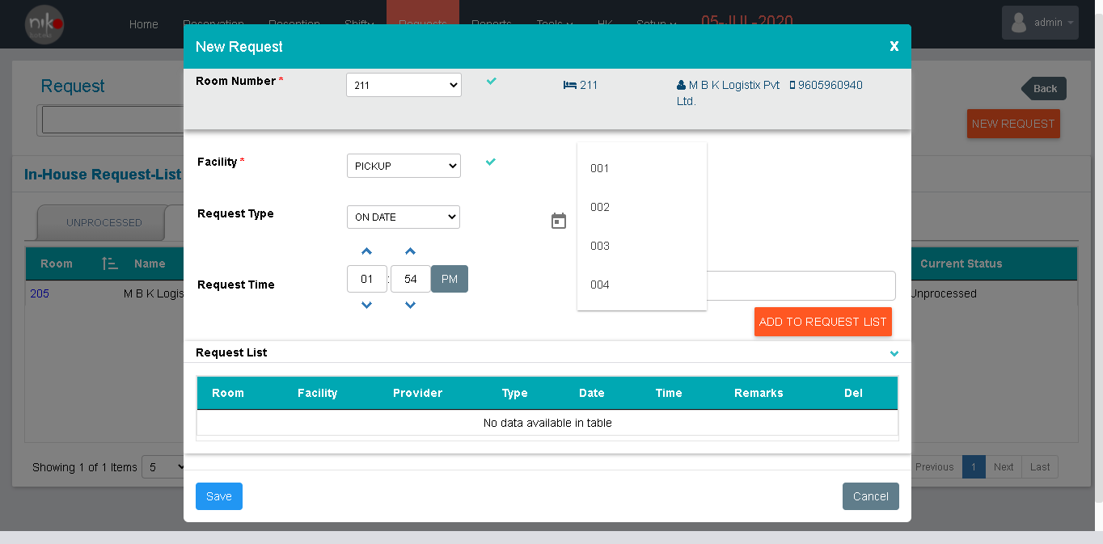

Fig: 5.2

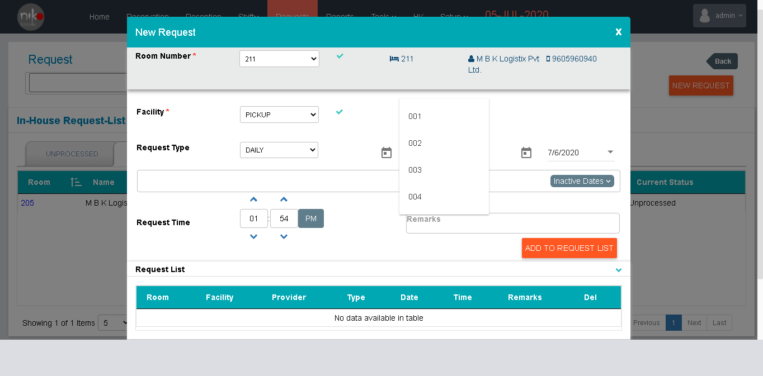  
fig: 5.3

Enter the details in the form. User can select the room number from the dropdown shown in the window. When user selects the room number, the details will show in the screen. Then select the facility from the dropdown. There is two type of request is provided, daily and on date: when user select the on date portion then enter the other details as per the on date service. If user select the daily portion, then the screen will change as per the selected portion and enter the details as per the request then click the save button to submit the request.

# Reports

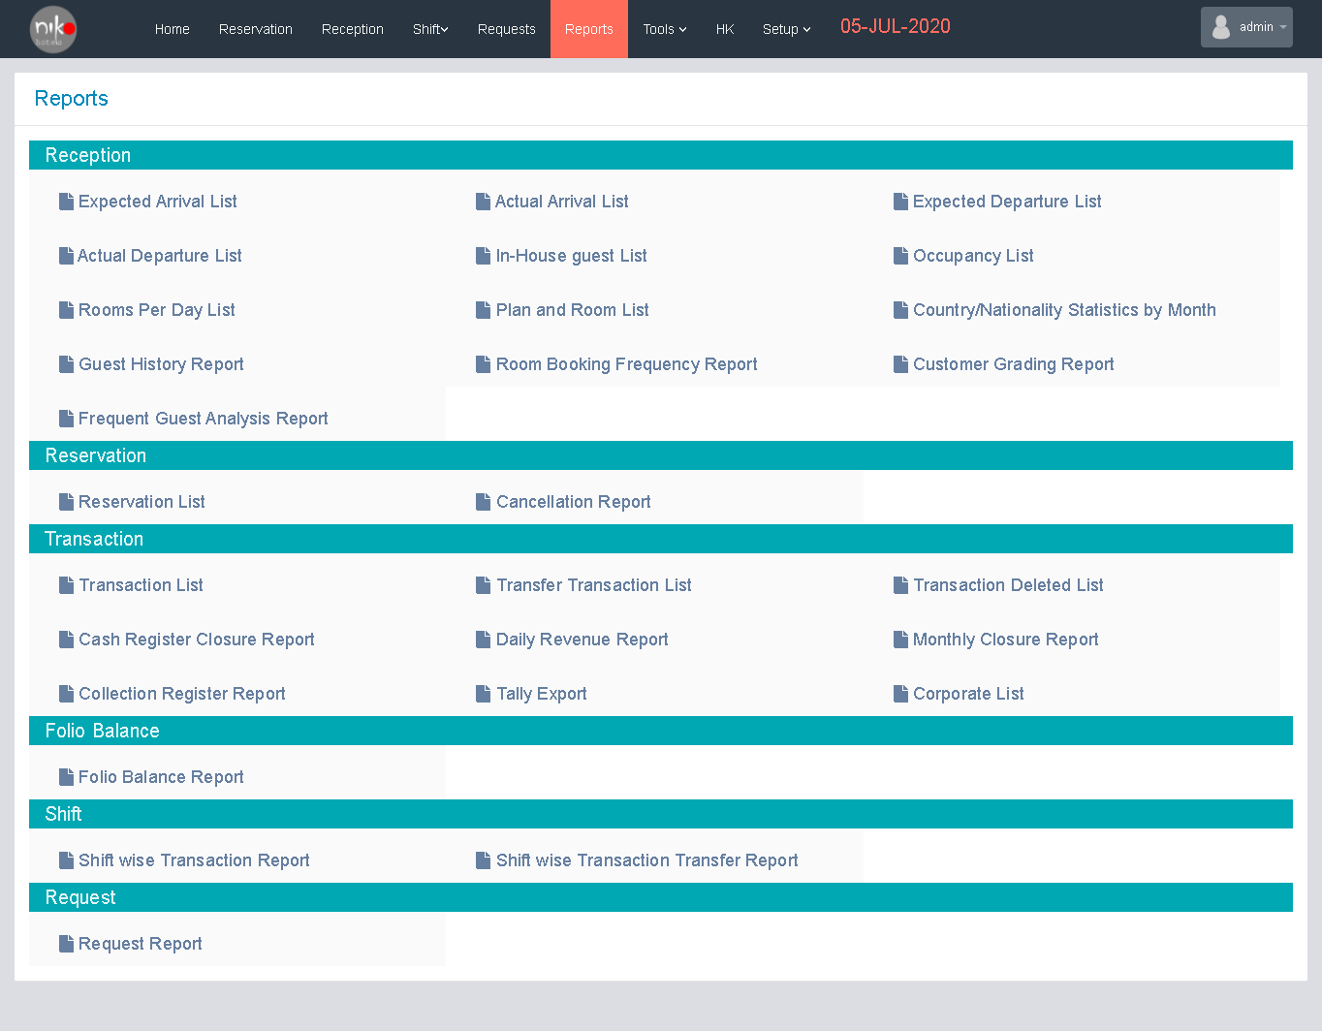

Fig: 6.1

The user can get the details about the hotel in the pdf or excel format from the report module. User can get all the reports.

1. Reception Reports
2. Excepted Arrival list
3. Actual Departure list
4. Rooms per Day list
5. Guest history report
6. Frequent guest analysis report
7. Actual arrival list
8. In-house guest list
9. Plan and room list
10. Room booking frequency report
11. Excepted departure list
12. Occupancy list
13. Country/Nationality statistics by month
14. Customer grading report
15. Reservation Reports
16. Reservation list
17. Cancellation report
18. Transaction Reports
19. Transaction list
20. Transfer transaction list
21. Transaction deleted list
22. Cash register closure report
23. Daily revenue report
24. Monthly closure report
25. Collection register report
26. Tally export
27. Corporate list
28. Folio Balance
29. Folio Balance report
30. Shift Reports
31. Shift wise transaction report
32. Shift wise transaction transfer report
33. Request
34. Request report

These are the reports provided in this module. User can see the reports in PDF format or excel document and user can download the reports in PDF format for further reference. When user click the links shown in the screen, then popup a window for enter the details for filter the reports from the list.

# Shifts

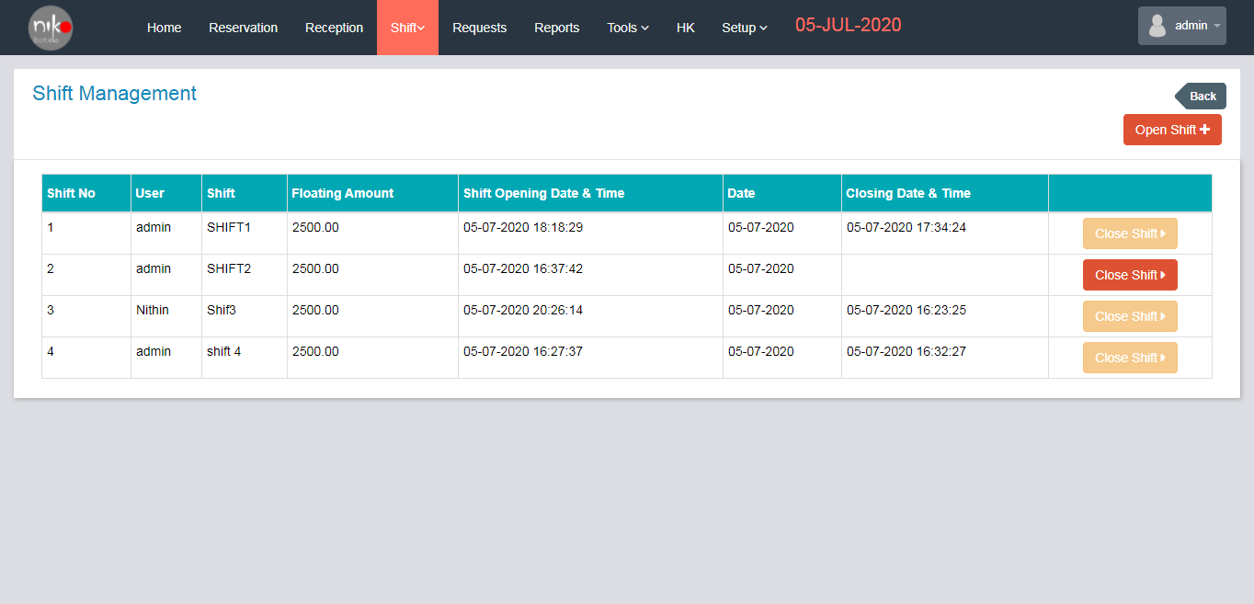

Fig: 7.1

Functionalities

When user clicks the shift button from the top navigation, a new window will show as given above.

Here user can see the list of shifts in the hotel and user can close the shift by clicking the close shift button in the list. When user click the close shift button from the list then popup a window shown as below for closing the shifts.

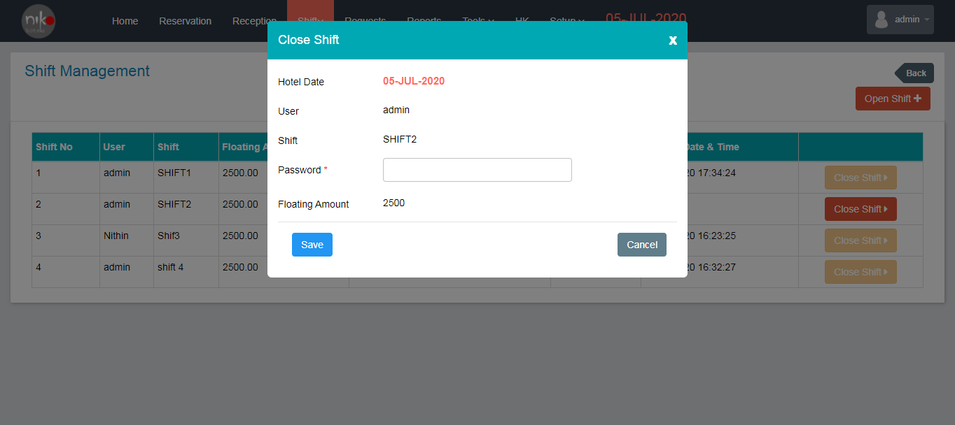

Fig: 7.2

User can enter the password to close the shift then click the save button to close the shift. User can open a new shift in this screen by clicking the open shift. When user clicks the open shift button then popup a new window had shown as below.

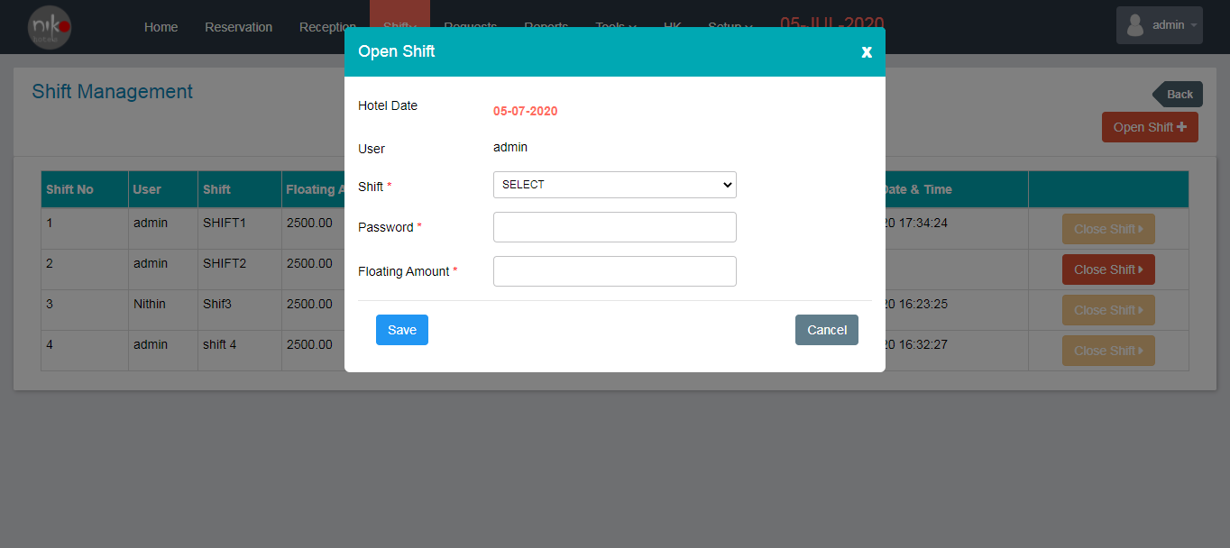

Fig 7.3

In this form user can see the hotel date, user name, then user can enter

# Tools

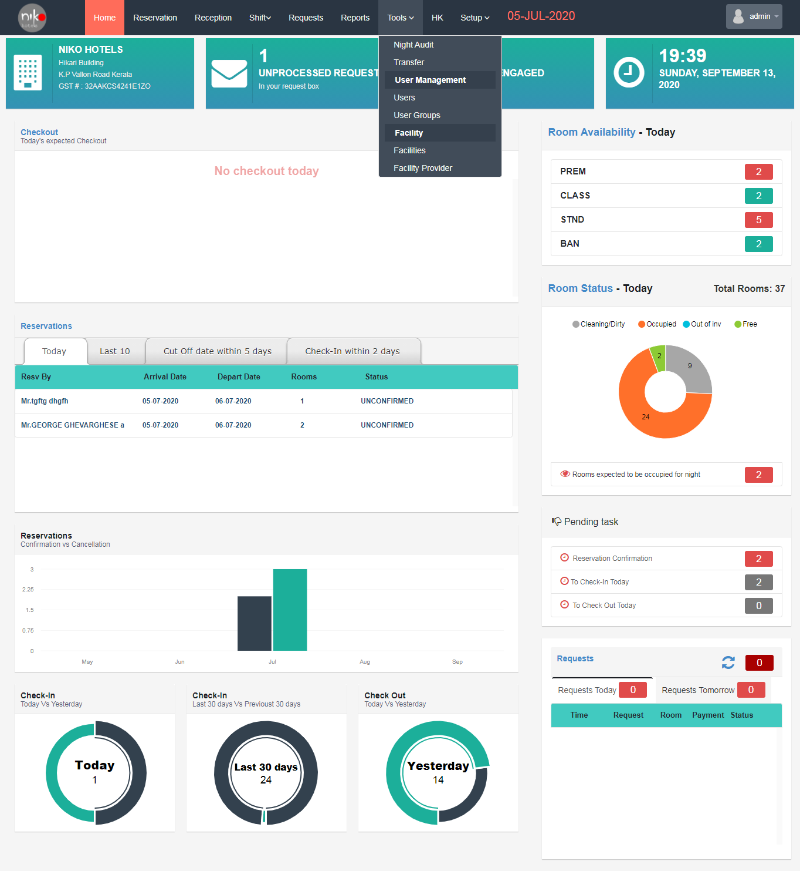

Fig: 8.1

In tools module, there are some options provided for the management of the hotel facilities. Night Audit, Transfer, Users, User Group in user management section, then facilities and facility provider in facility management section: these are the features provided in the tools module.

Functionalities

1. Night Audit

In Night Audit section user can see the pre night audit checklist on the screen. User can see the count of expected, no-show, in-house details as numbers in the top most rows on the screen. Then there is two tables shown in the window; Excepted departure and Excepted arrivals. In Excepted departure, user can see the list about the excepted departure, list contents are Room, Arrival date, Name, Phone, Folio balance and Extend stay. Then in expected arrivals, list contents are Name, Reserved date, Room type, and phone and Reserve status.

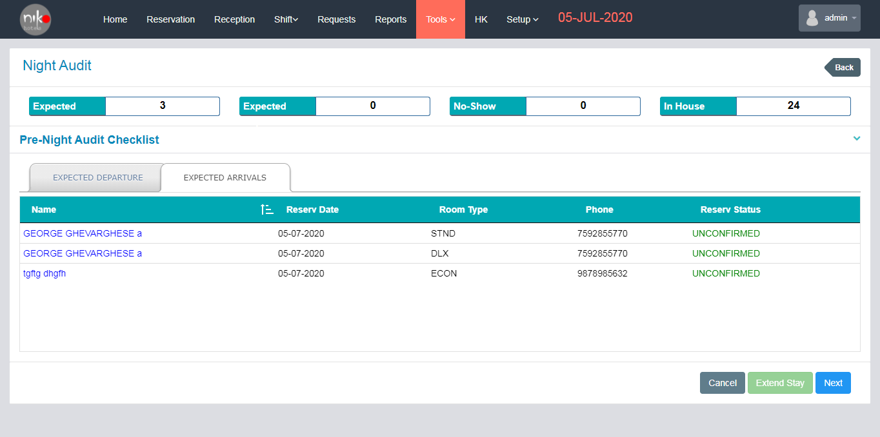

Fig: 8.1.1

When user select the expected arrivals list, a list is shown as above and user can select any one from list it will popup the details as shown below.

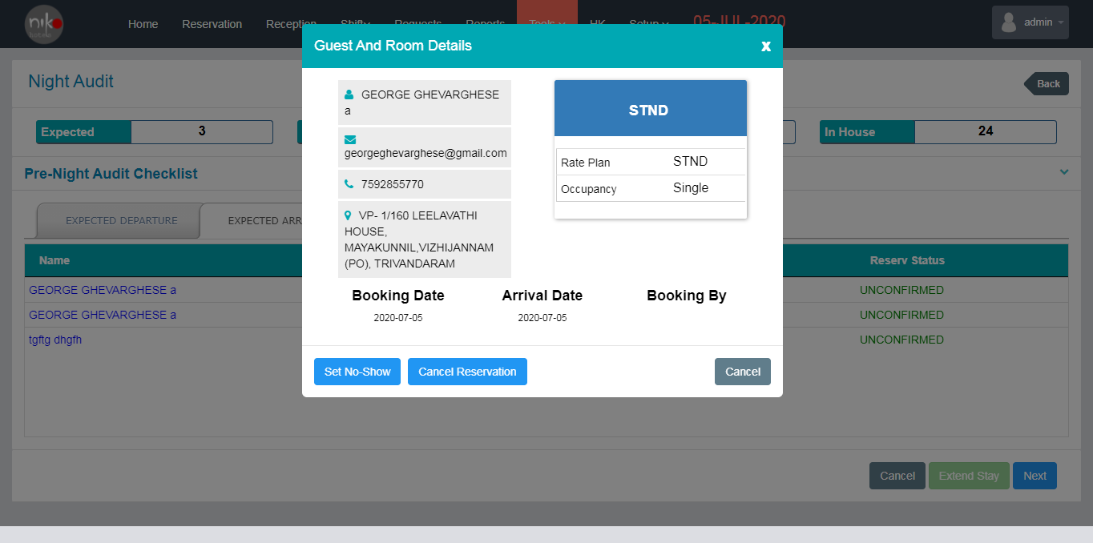

Fig: 8.1.2

User can cancel the reservation by clicking the cancel button in the window and also user can set the no-show details by clicking the button shown in the window.

1. Transfer

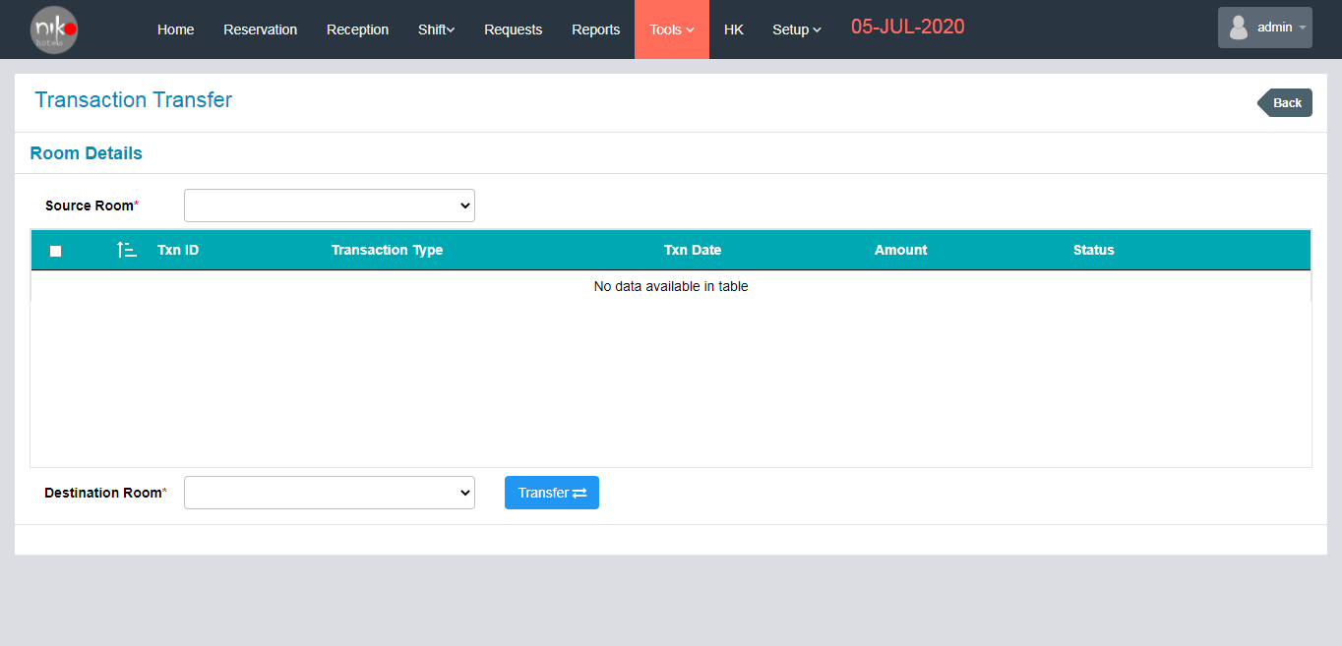

Fig: 8.2.1

In transfer section, user can transfer the room using this feature. User selects the source room and destination room then click transfers the button.

1. User

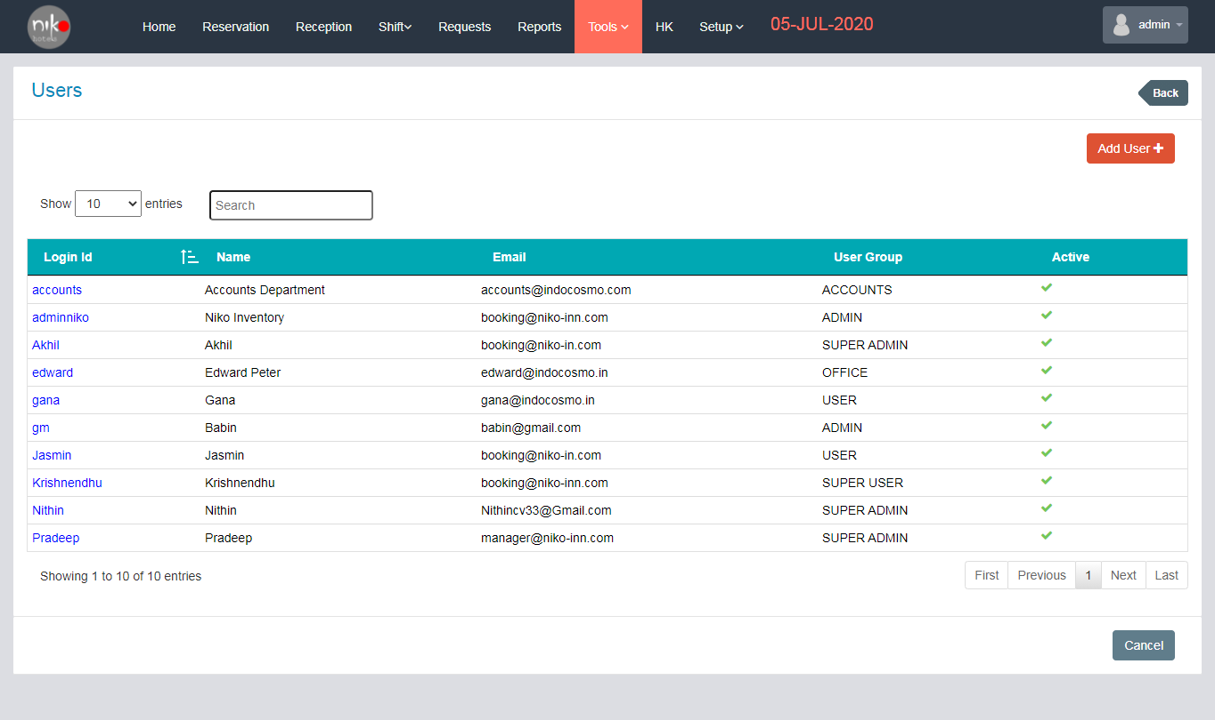

Fig: 8.3.1

User modules show the users details of the hotel.

List contents

1. Login id
2. Name
3. Email
4. User group
5. Active status

User can add new user by clicking the button “Add user”. When user click the add user button popup a new window as shown below.

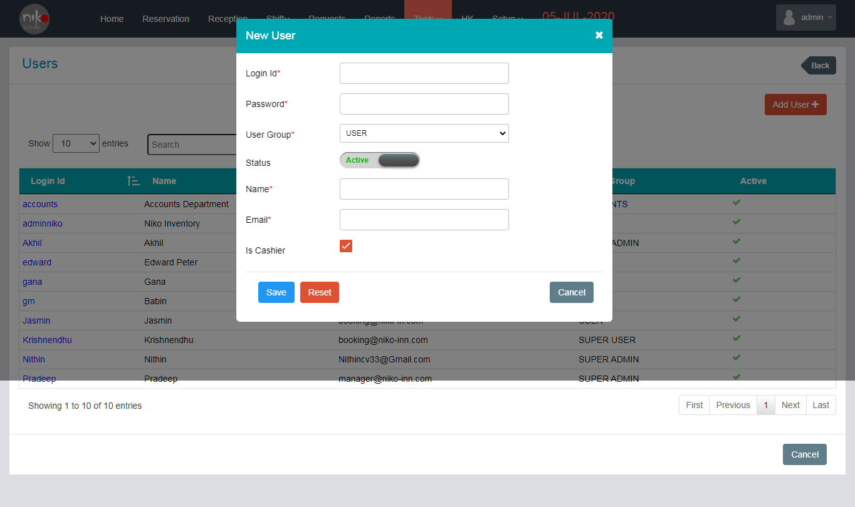

Fig: 8.3.2

Form contents

1. Login id : Enter the login id
2. Password : Enter the password
3. User group : select the user group from the dropdown
4. Status : enable the active status
5. Name : Enter the name of the user
6. Email : Enter the email id
7. Is cashier : check the checkbox if the user is a cashier

Then click the save button to add the user. User can reset the details by clicking the reset button and also cancel the process by clicking the cancel button.

1. User Groups

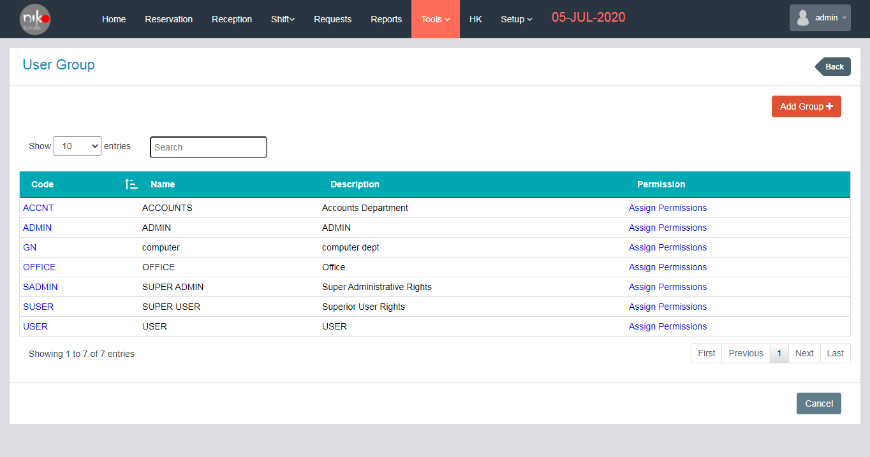

Fig: 8.4.1

In this section user can add the new user group and also show the list of user groups in the hotel.

List contents

1. Code
2. Name
3. Description
4. Permission

User can add the permissions by clicking the “Assign Permission” button in the list. When the user clicks the assign permission button, a new window will open as shown below.

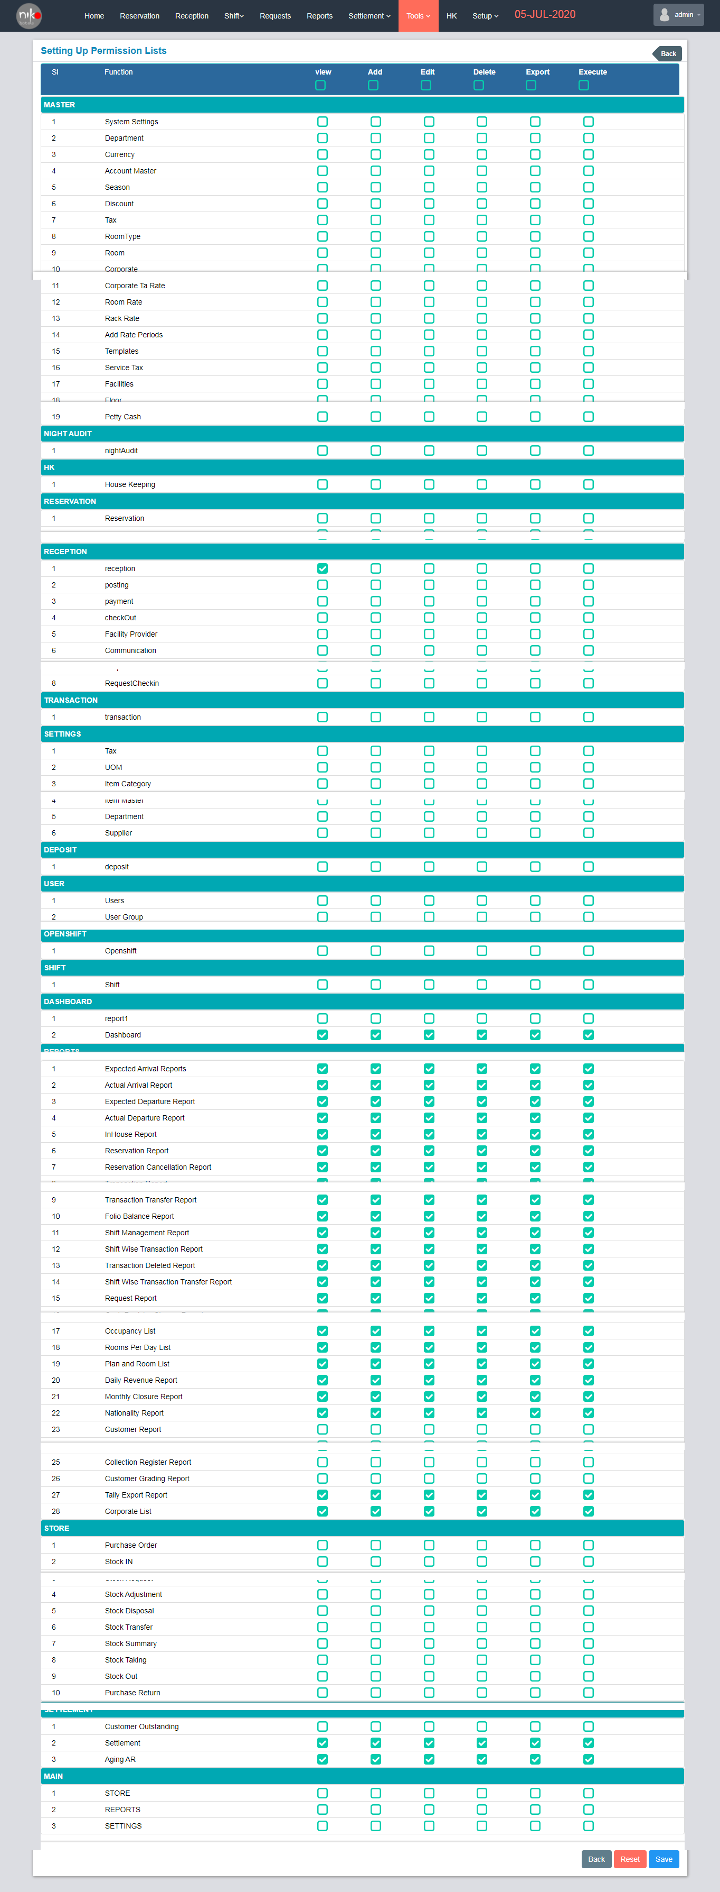

Fig: 8.4.2

User can set the permission of the user group and click the save button to add the permissions. Then user can also add new user by clicking the “Add Group” Button shown in the list screen. When the user clicks the Add Group Button, a popup will show as below.

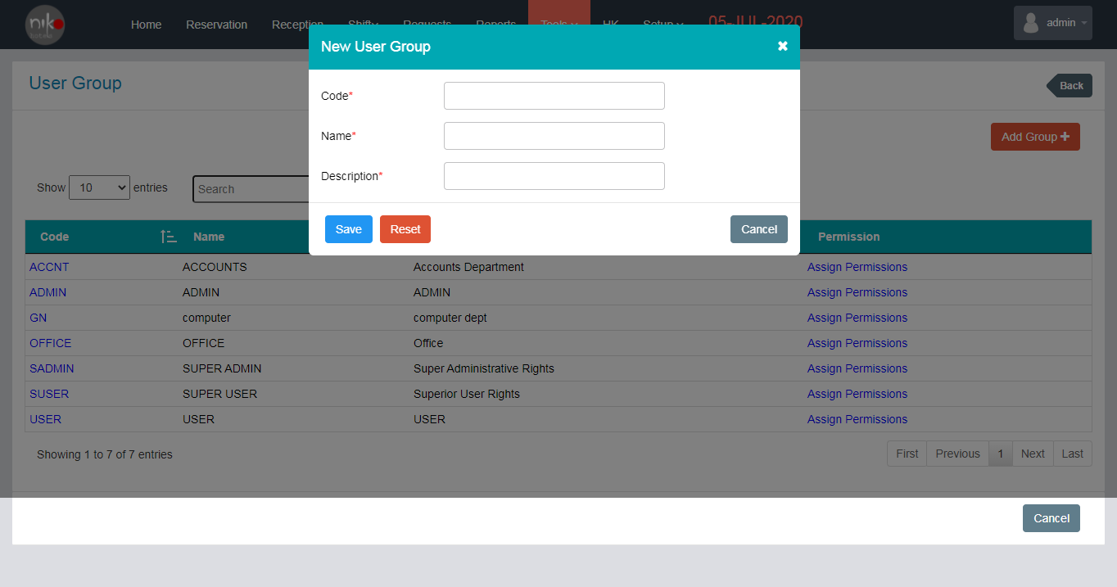

Fig: 8.4.3

Enter the user code, Name, Description then click the “Save “Button. User can reset the details by clicking the Reset button and user can cancel the process by clicking the Cancel button.

1. Facilities

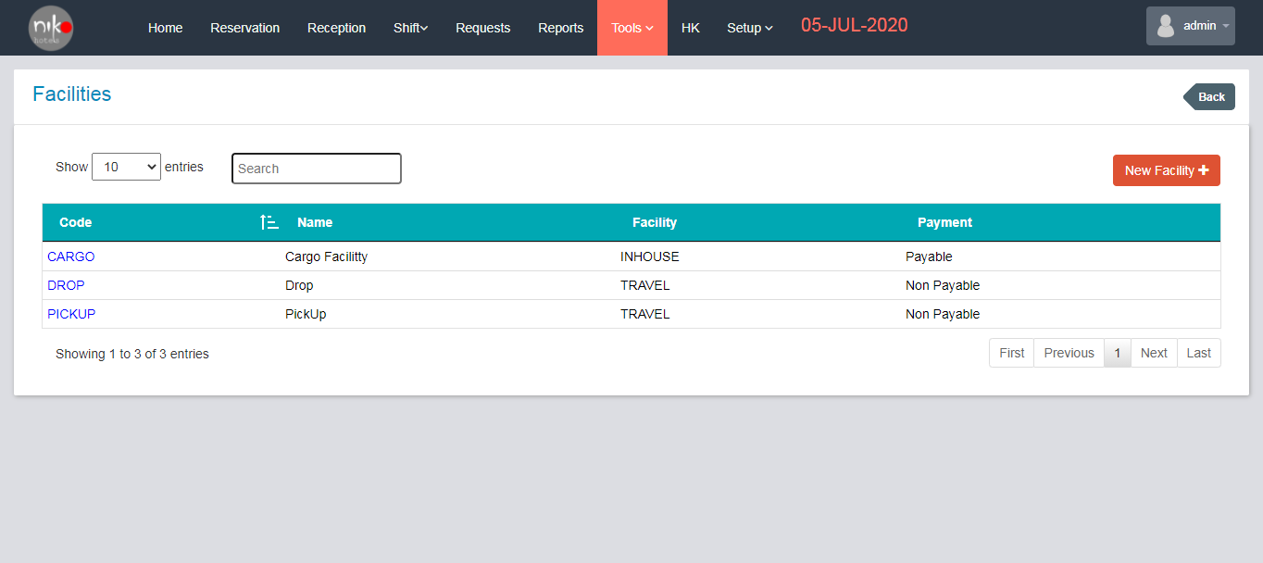

Fig: 8.5.1

User can see the list of facilities provided in the hotel.

List contents

1. Code
2. Name
3. Facility
4. Payment

User can add the new facility details by clicking the “New facility” Button. Popup a new window as shown below.

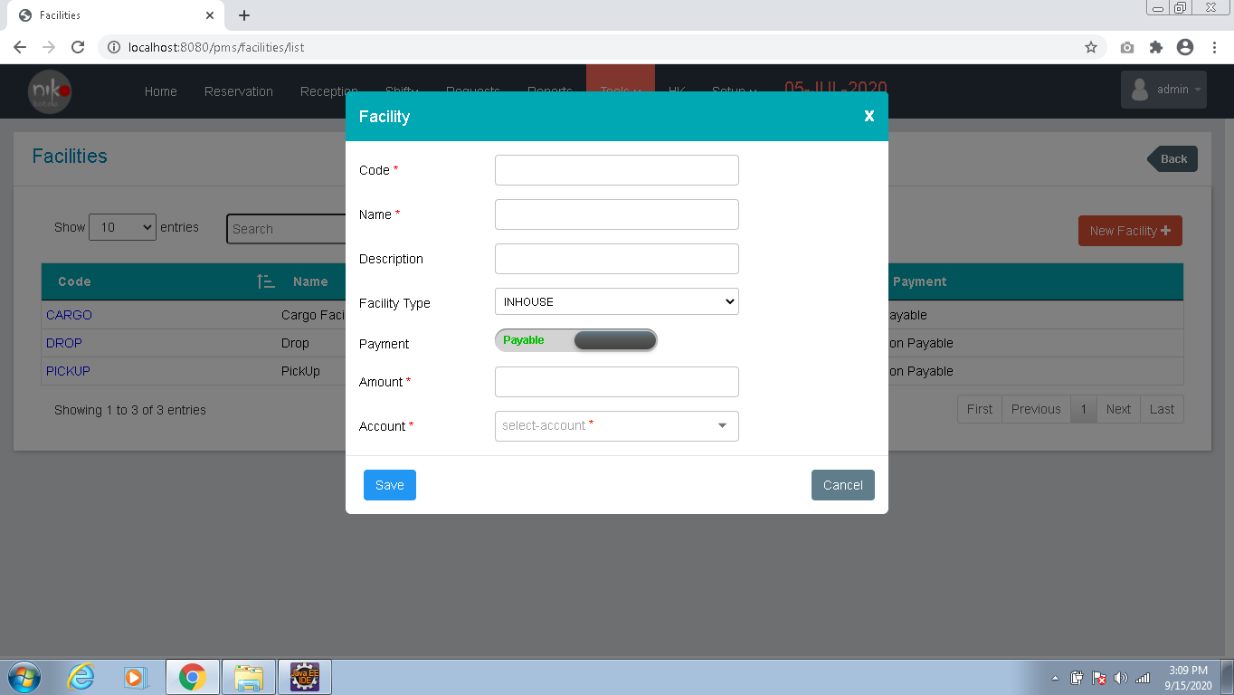

Fig: 8.5.2

User can add the details in the above form and click the save button to add the facility details.

Contents

1. Code : Enter the code
2. Name : Enter the name of the facility
3. Description : Enter the details
4. Facility type : Select the facility type from drop down
5. Payment : Enable the payment option
6. Amount : Enter the amount
7. Account : Select the account type from the dropdown

These are the details needed for adding new facility.

1. Facility Provider

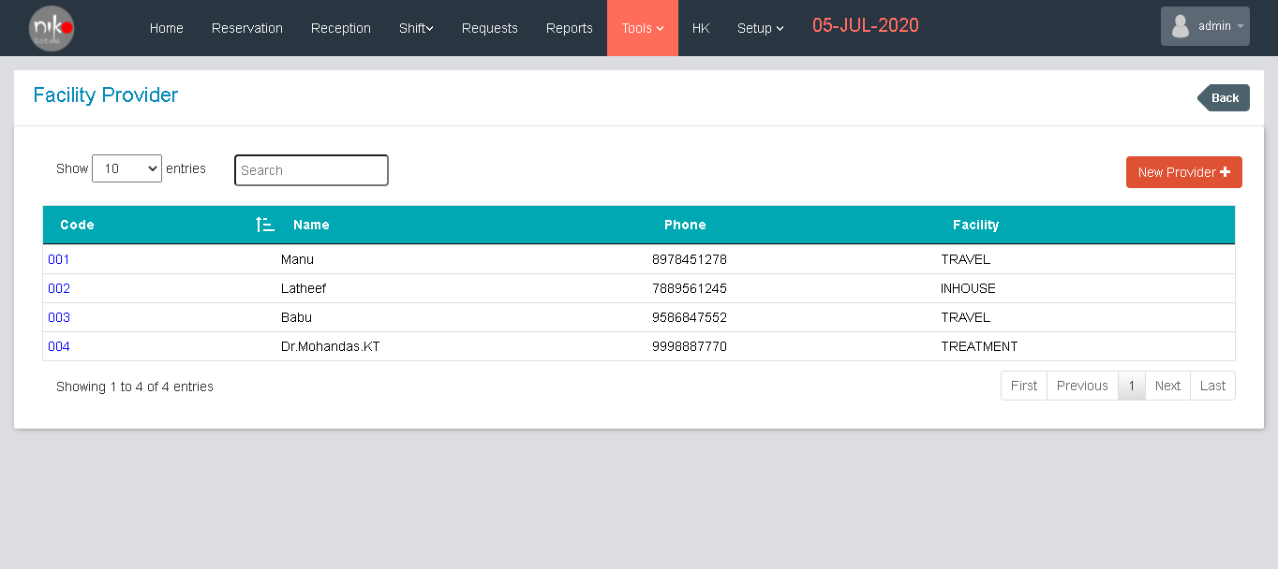

Fig: 8.6.1

User can add, edit and view the list of facility providers in the hotel. User can edit the facility provider details by clicking the link provided in the code column in the table. When user clicks the code from the list, popup a window for edit the details as shown below.

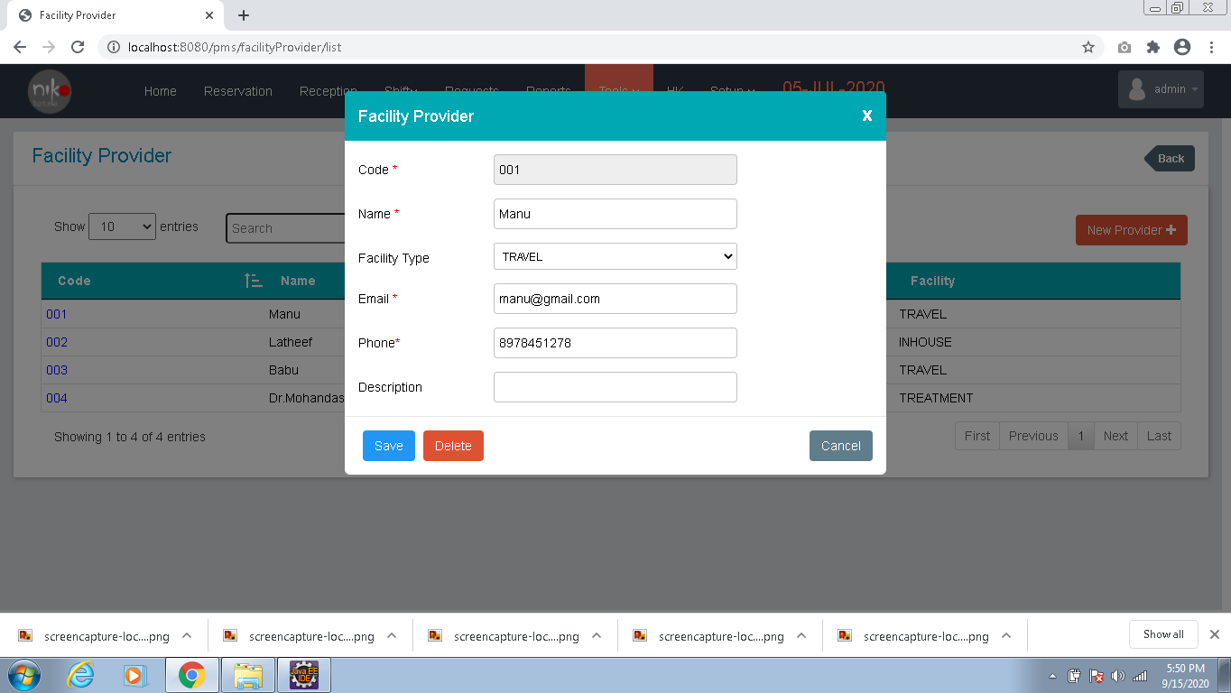

Fig:8.6.2

User can edit the details of the facility provider in this screen and click the save button to make the change.

Then user can also add the facility provider by clicking the “New provider” button on the screen. When user clicks the button, popup a new window as shown below.

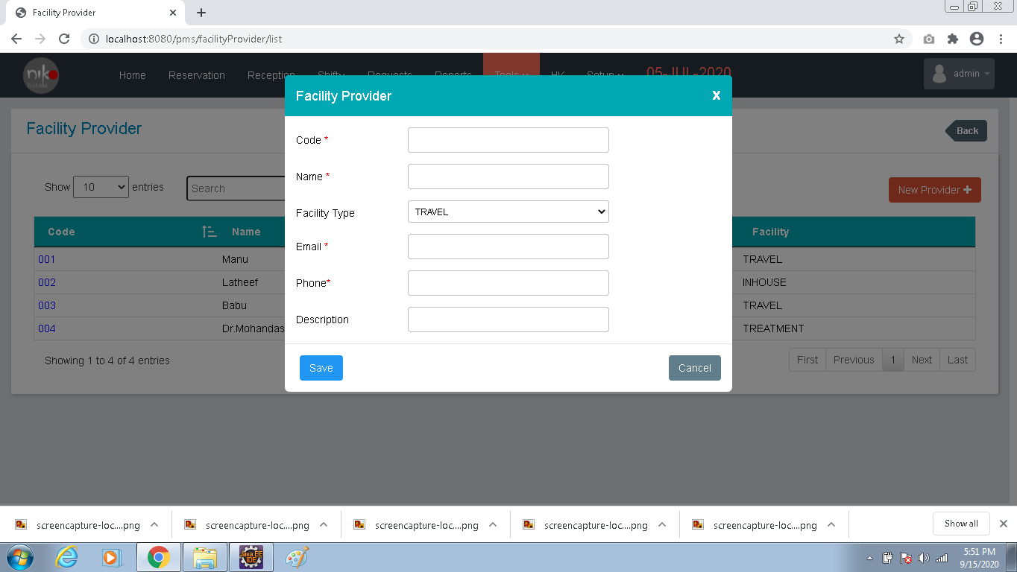

Fig:8.6.3

|  |  |  |
| --- | --- | --- |
| SL No. | Contents | Descriptions |
| 1 | Code | Enter the code |
| 2 | Name | Enter the name of the facility provider |
| 3 | Facility type | Select the type from the dropdown |
| 4 | Email | Enter the email address |
| 5 | Phone | Enter the phone number |
| 6 | Description | Enter the description |

Table: 8.1

User can enter the details as per the above instructions and click the save button to save the details.

# HK

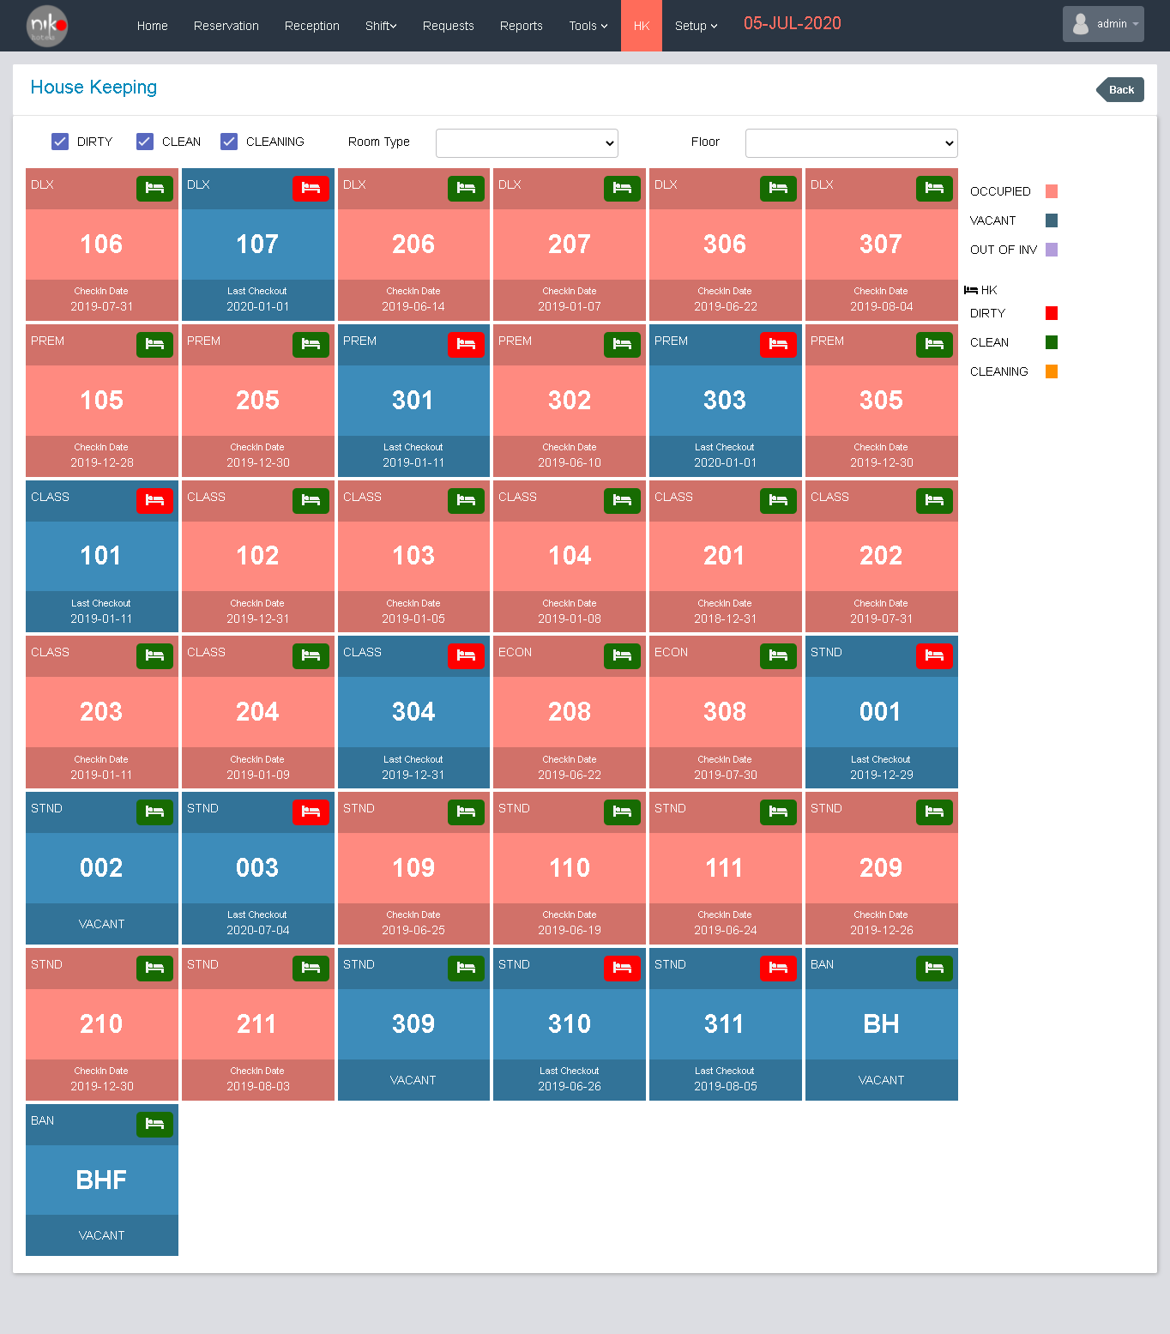

Fig: 9.1

User can view the house keeping in this screen. User can also filter the rooms by room type and floor selected from the dropdown. User can view the cleaned rooms, dirty rooms and cleaning rooms separately.

# Setup

User can setup the system in this module. System setup includes System settings, departments, currency, account master, seasons, discount, tax, shifts, room type, floor, corporate Ta, room rate, corporate.

Functionalities

1. System Settings

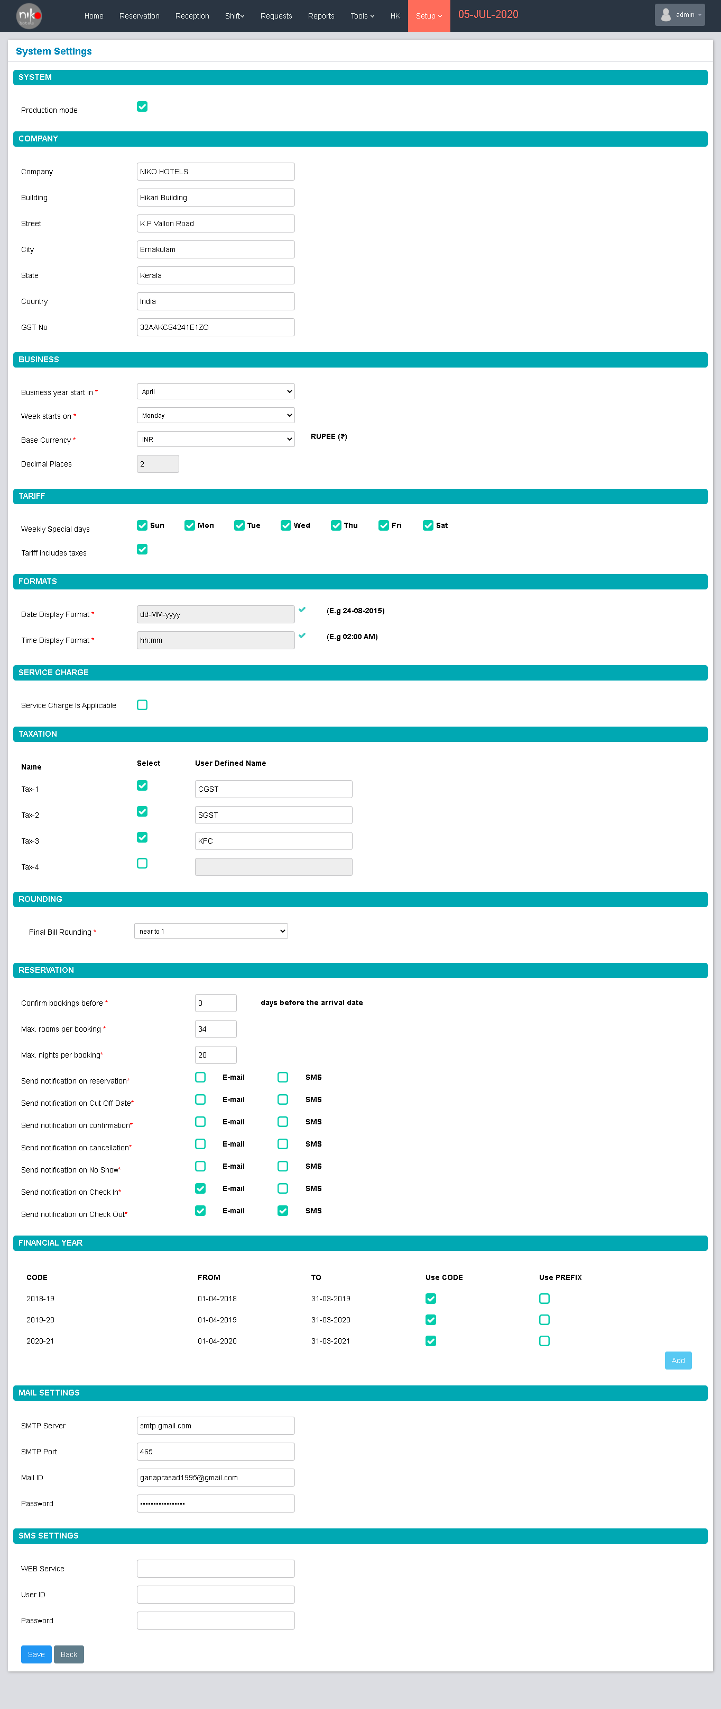

Fig: 10.1.1

User can set the system setting in this module. If the system is in the production mode mark the check box as checked. Then next section is entering the company details.

|  |  |  |
| --- | --- | --- |
| SL No. | Contents | Description |
| 1 | Company | Enter the company name |
| 2 | Building | Enter the building no or name |
| 3 | Street | Enter the street name |
| 4 | City | Enter the city name |
| 5 | State | Enter the state name |
| 6 | Country | Enter the country name |
| 7 | GST No | Enter the GST number of the company |

Table : 10.1

Then enter the business details in the next section

|  |  |  |
| --- | --- | --- |
| SL No. | Contents | Description |
| 1 | Business year start in | Select the month from the dropdown |
| 2 | Weeks start in | Select the day from the dropdown |
| 3 | Base currency | Select the base currency |
| 4 | Decimal places | Enter the decimal places in number |

Table : 10.2

Then add the traffic details in the next section. Mark the checkboxes in weekly special days and if user adds traffic tax then mark the checkbox enable.

The next section is formats used in the system. The date and time display in the system. Select the proper format for date and time.

If company applies any service charges then enable the check box shown in the screen. Then set the taxation details in the next section. Then set the rounding details. Select the suitable rounding from the drop down.

Then set the reservations details as per the company policy. Then the next section user can add the financial year details by clicking the add button, then mark if its uses codes or prefix by enable the checkbox.

Then the next section mail setting, enter the details of SMTP Server name, port number, mail id and password.

Then next section is SMS setting if the company uses any SMS services, add the web service name, user id and password details. Finally verify all the details and click the save button.

1. Department

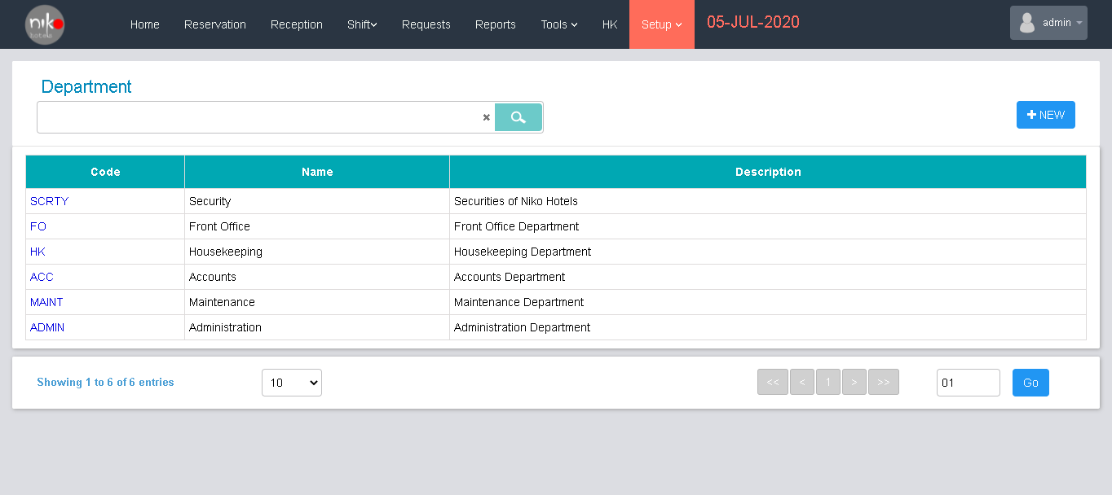

Fig:10.2.1

Here user can add the department details, edit the details and view the details. When user can edit the department details by clicking the link given in the code column. Then popup the window as shown below.

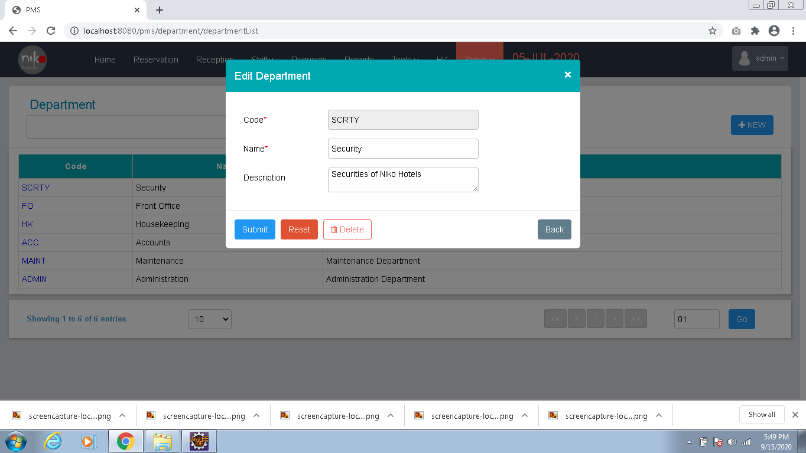

Fig: 10.2.2

User can edit the details of department like name and description then click the submit button to make the changes. User can delete the entry by clicking the delete button.

User can also add a new department by clicking the “New” button seen in the screen. When user clicks the new button, popup a new window as shown below.

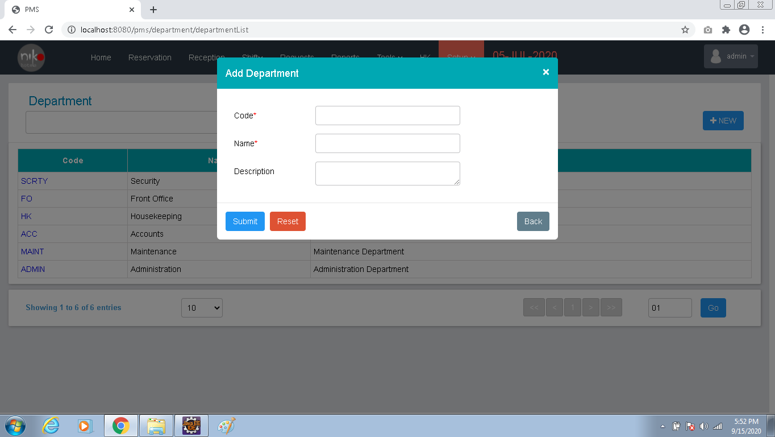

Fig:10.2.3

Enter the department code, name and description, then click the submit button for adding the new department.

1. Currency

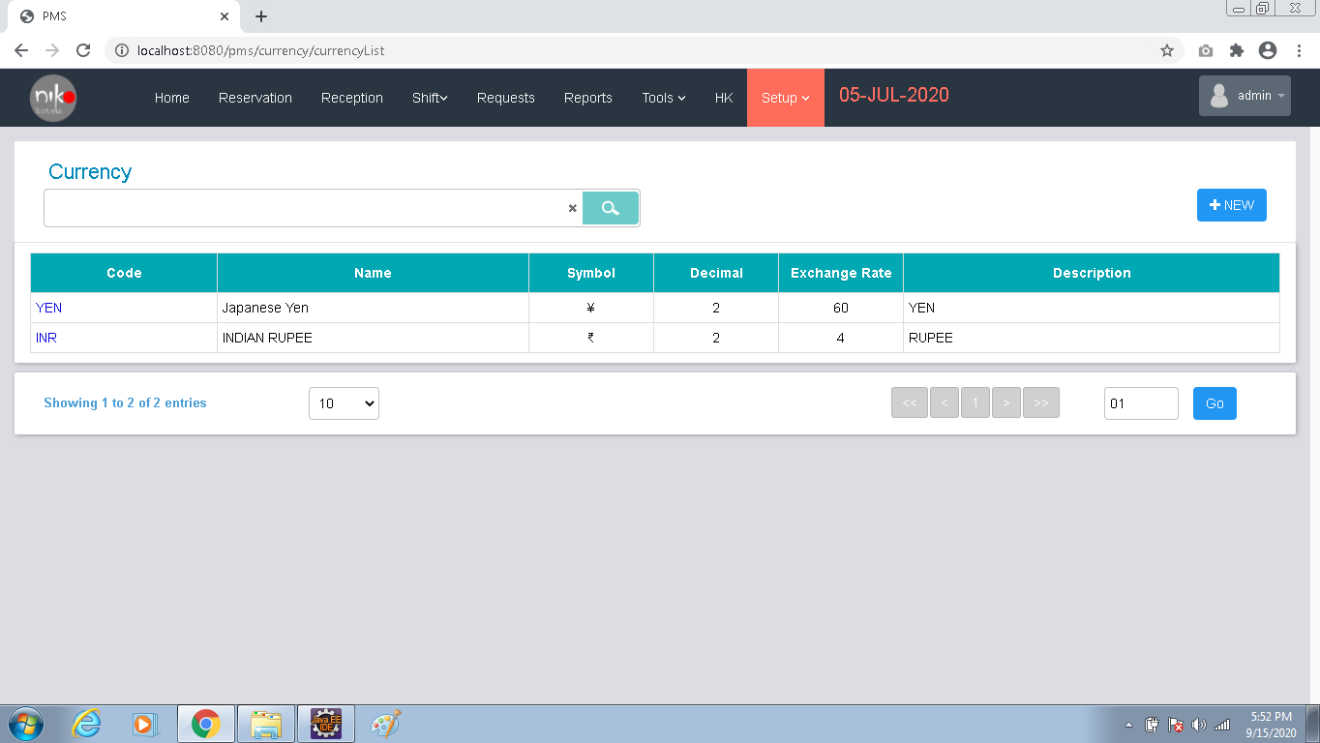

Fig:10.3.1

In this section user can edit, add and view the details of currency used for transactions in the company.

When user clicks the link shown in the code column, popup a window for editing the details as shown below.

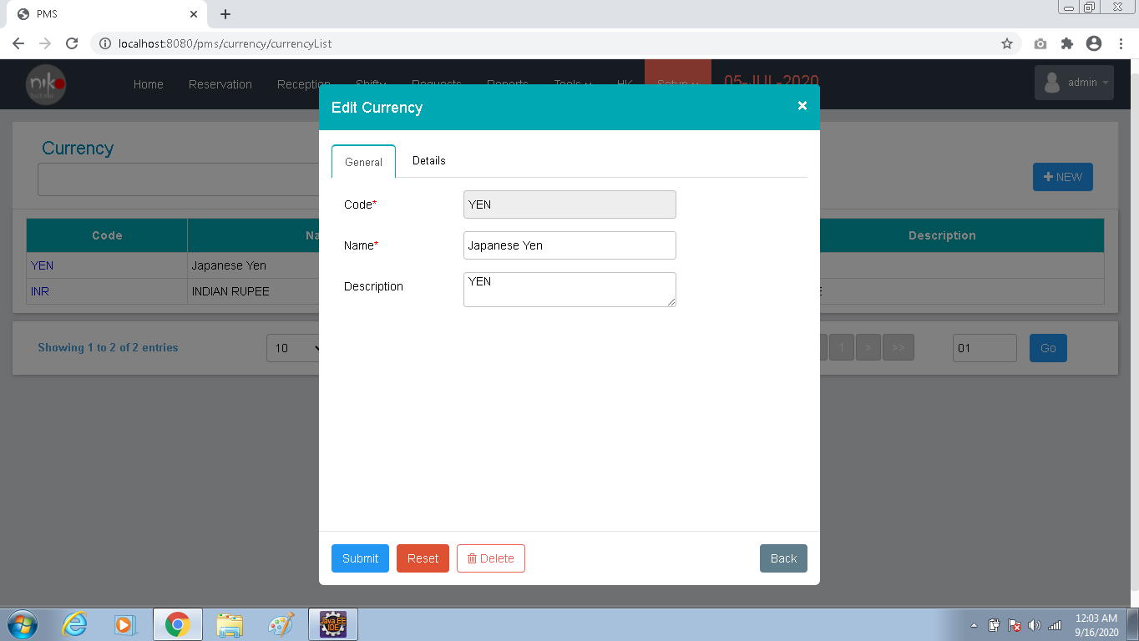

Fig: 10.3.2

User can edit the details from this window and click the submit button to make the change. User can delete the details by clicking the delete button.

User can add new currency details by clicking the New Button. Add currency window as shown below.

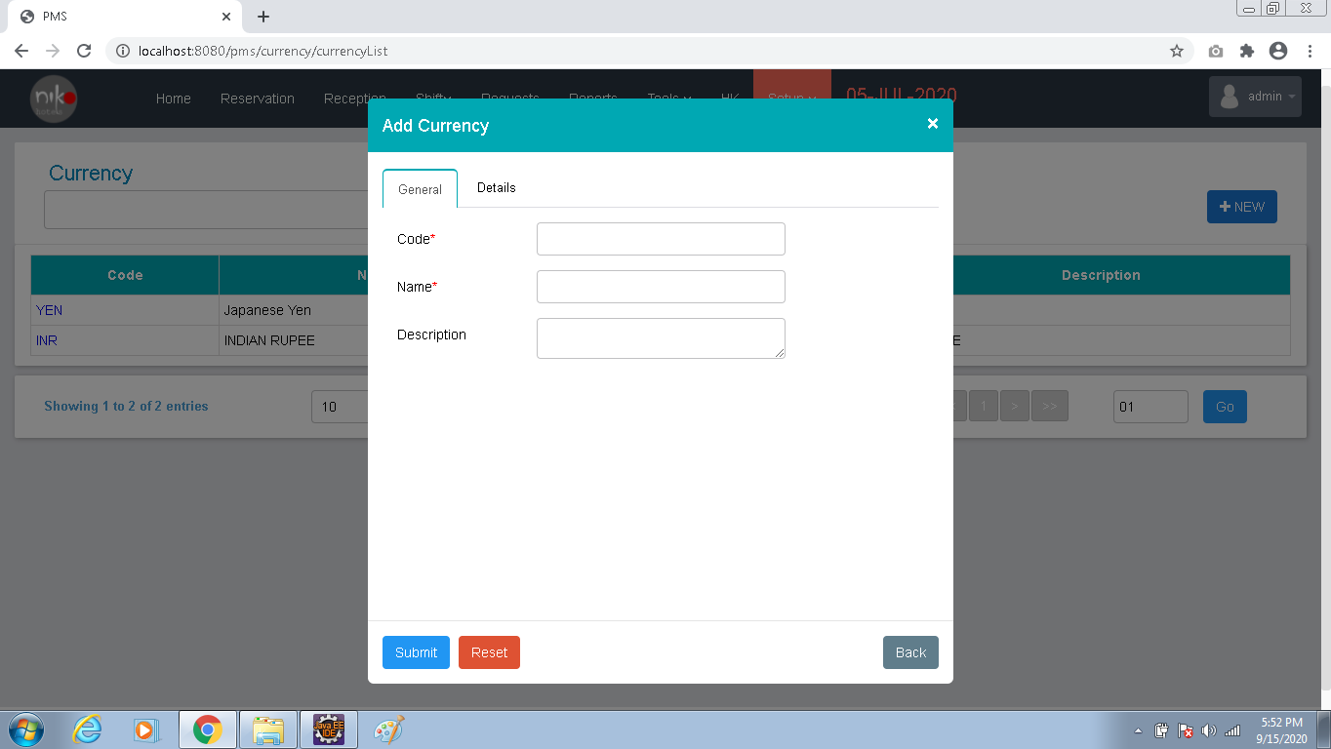

Fig: 10.3.3

Enter details as per the table given below.

|  |  |  |
| --- | --- | --- |
| SL No | Contents | Description |
| 1 | Code | Enter the unique code |
| 2 | Name | Enter the name of currency |
| 3 | Description | Add the description about the currency |
| 4 | Symbol | Add the symbol used |
| 5 | Fraction | Add the fraction |
| 6 | Fraction symbol | Add the fraction symbol |
| 7 | Decimal place | Add the decimal places used |
| 8 | Exchange rate | Add the exchange rate |
| 9 | Updated date | Add the current date or updated date |

Table: 10.3.1

Add the details and click the submit button to add the new entry.

1. Account master

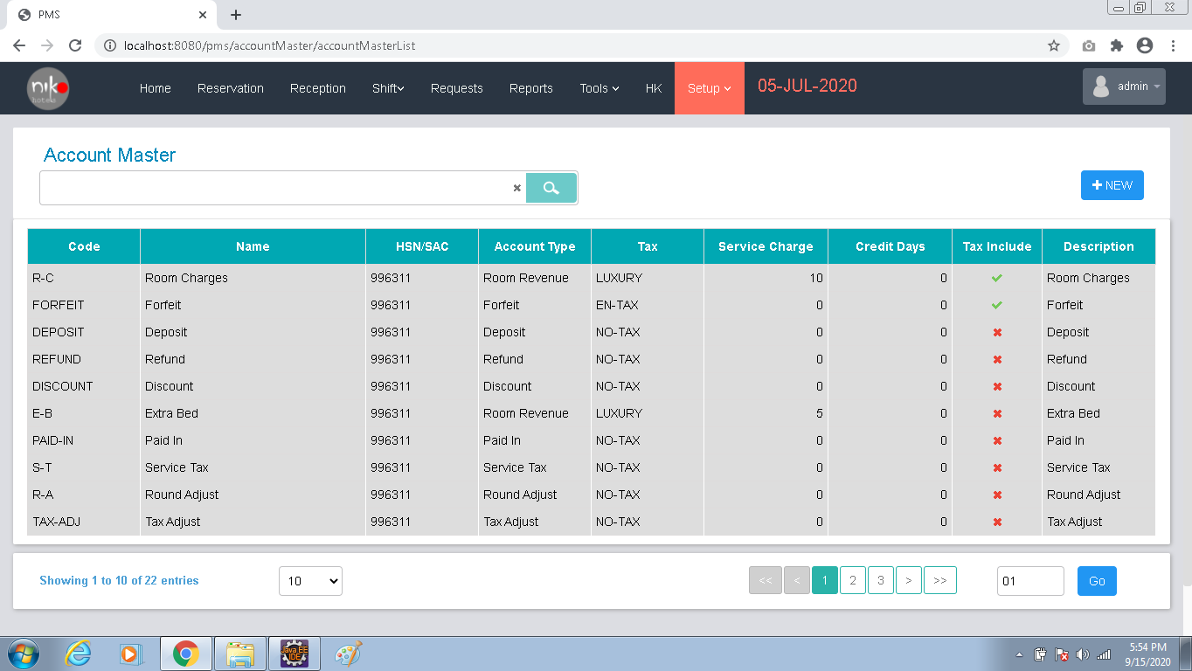

Fig: 10.4.1

Here user can add and view the details of Account master details. When user clicks the new button shown in the screen, a popup will shown as below to add the account master details.

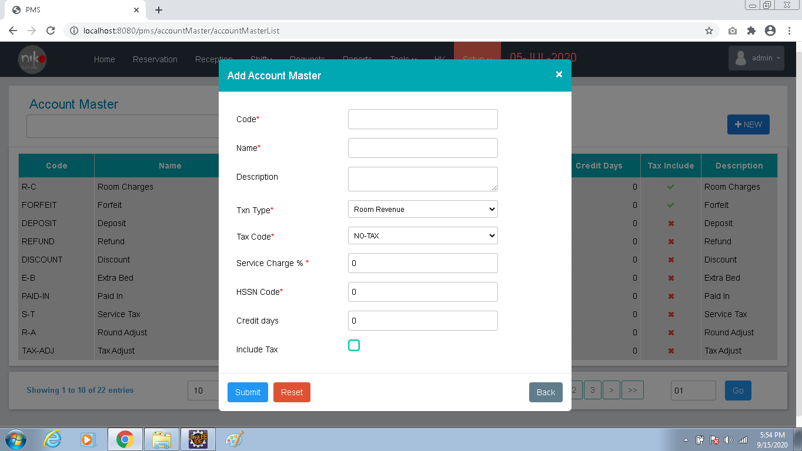

Fig: 10.4.2

|  |  |  |
| --- | --- | --- |
| SL No | Contents | Description |
| 1 | Code | Enter the unique code |
| 2 | Name | Enter the name |
| 3 | Description | Add the description |
| 4 | Txn type | Select the transaction type from the dropdown |
| 5 | Tax code | Select the tax code from the dropdown |
| 6 | Service charge | Enter the service charge |
| 7 | HSSN code | Add the HSSN Code |
| 8 | Credit days | Add the credit days |
| 9 | Include tax | If tax included, enable the checkbox |

Table: 10.4.1

Add the proper data as per the table shown above and click the submit button to add the new entry.

1. Seasons

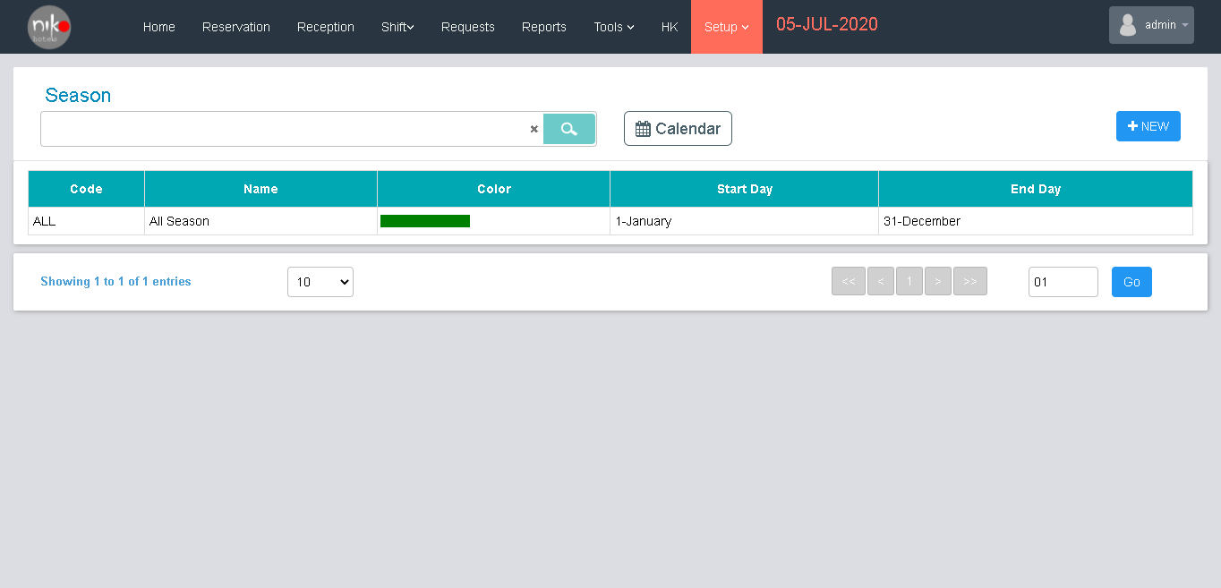

Fig: 10.5.1

Here user can add and view the details of seasons. User can add new season by clicking new button shown in the screen.

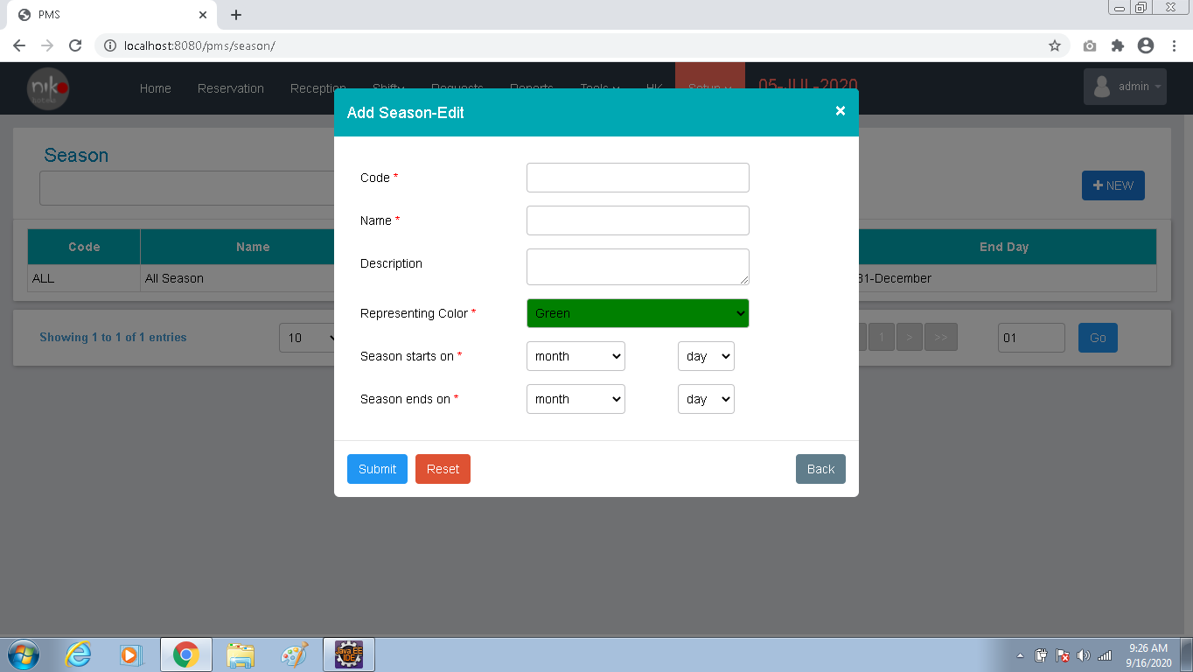

Fig: 10.5.2

|  |  |  |
| --- | --- | --- |
| Sl. No. | Contents | Description |
| 1 | Code | Enter the unique code |
| 2 | Name | Enter the name of the season |
| 3 | Description | Enter the description |
| 4 | Representing color | Select the color from the dropdown |
| 5 | Season starts on | Select the month and day |
| 6 | Season ends on | Select the month and day |

Table: 10.5.1

Add the proper data and click the submit button to add the entry.

1. Discount

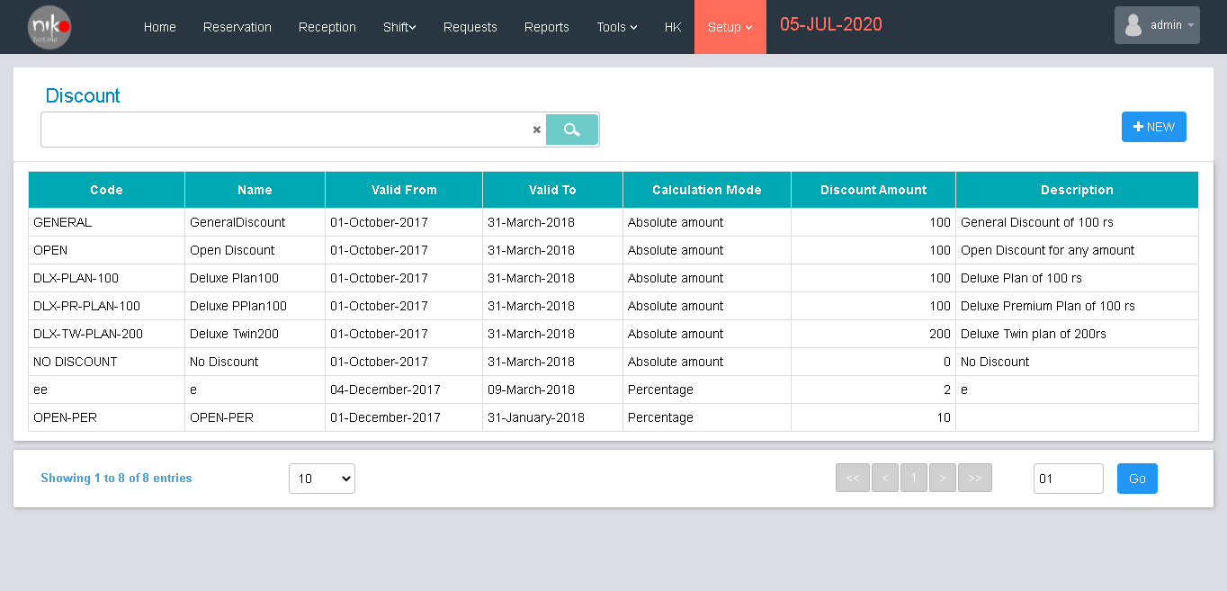

Fig: 10.6.1

Here user can add and view the details discounts provided in the company. User can add new discount by clicking the new button.

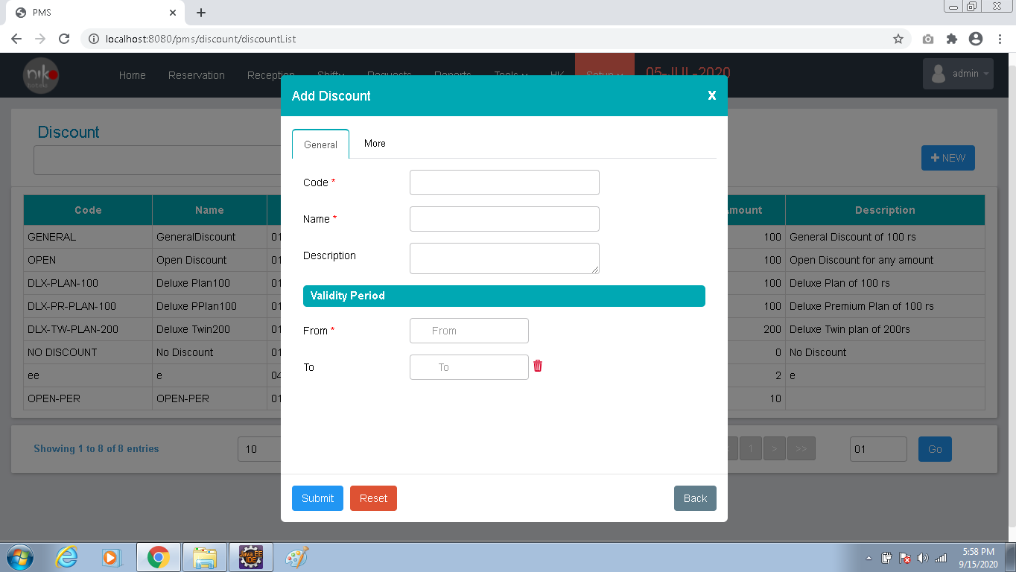

Fig: 10.6.2

|  |  |  |
| --- | --- | --- |
| Sl. No. | Contents | Description |
| 1 | Code | Enter the unique code |
| 2 | Name | Enter the name |
| 3 | Description | Enter the description |
| 4 | From | Select the from date |
| 5 | To | Select the to date |
| 6 | Discount type | Select the discount type from the dropdown |
| 7 | Rate plan | Select the rate plan from the dropdown |
| 8 | Calculation mode | Select the calculation mode from the dropdown |
| 9 | Discount amount | Enter the discount amount |

Table: 10.6.1

Enter the details as per the table then click the submit button to add the new entry.

1. Tax

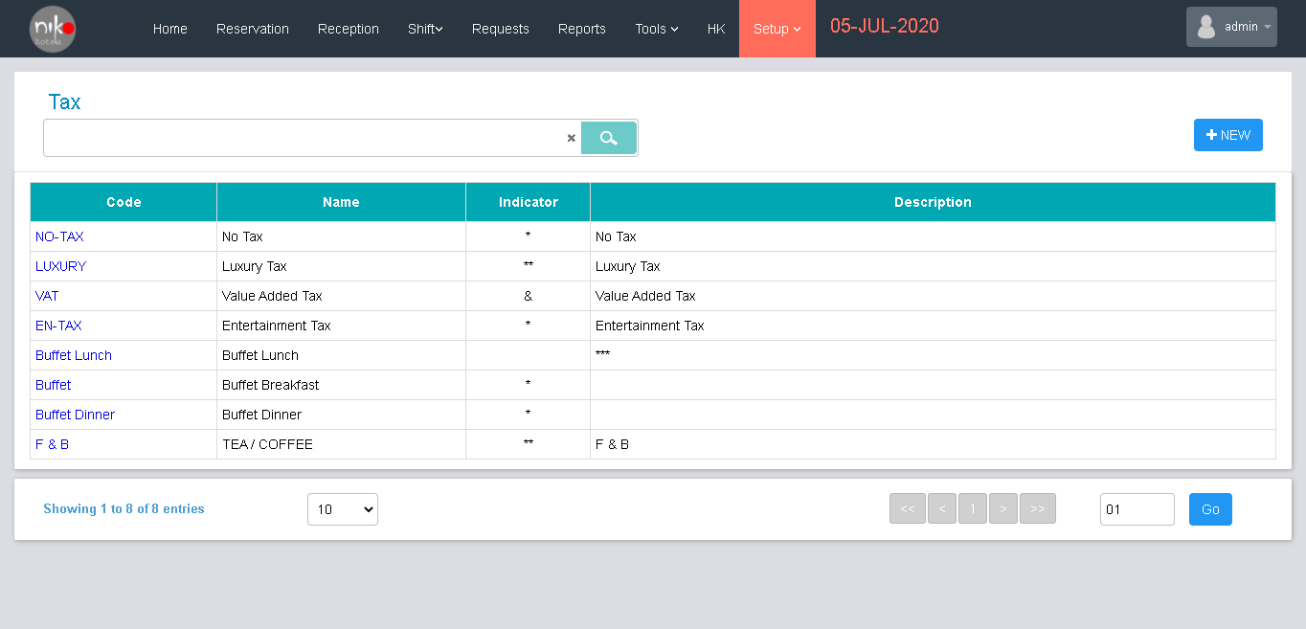

Fig: 10.7.1

Here user can add, edit and view the details of taxes included in the company. When user select the tax entry from the table, popup a edit screen as shown below.

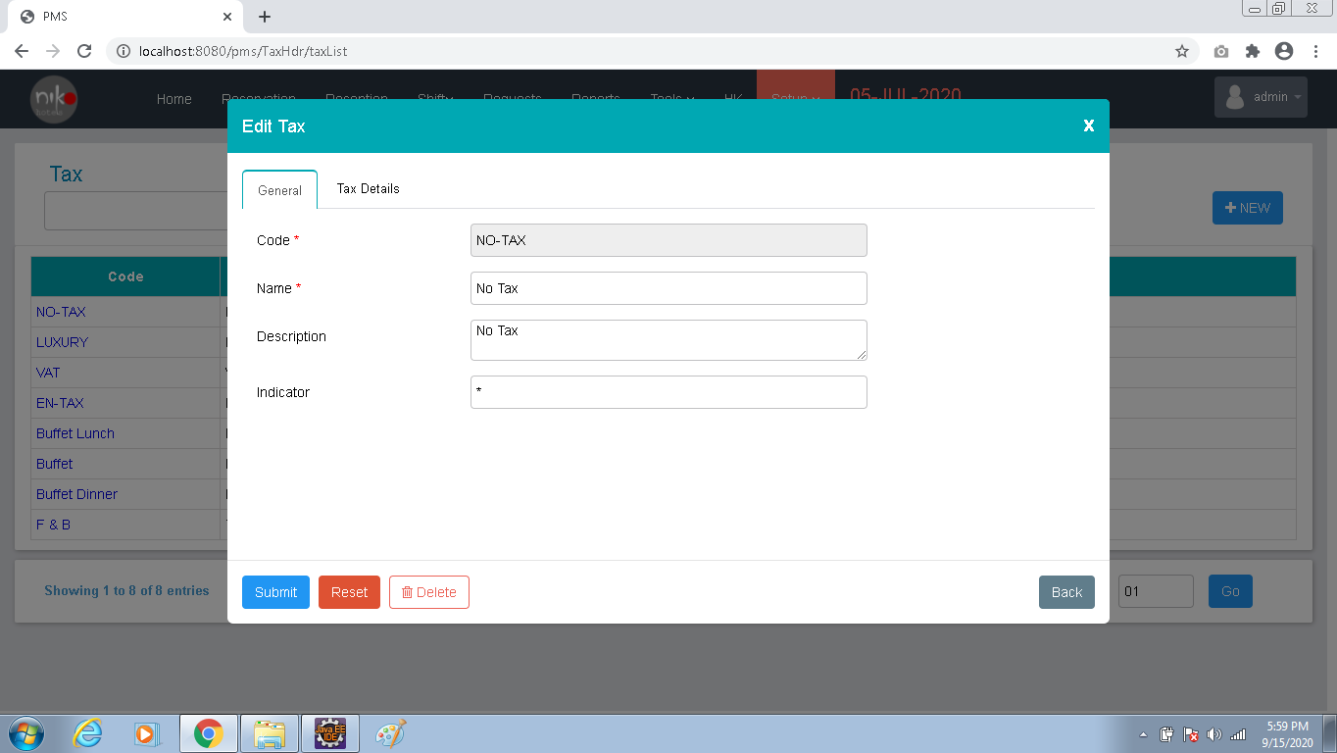

Fig: 10.7.2

Edit the details as per the changes needed and click the submit button to make the change. User can delete the entry by clicking the delete button. User can also add the new entry by clicking the new button shown in the screen and popup a new window for add the new entry as shown below.

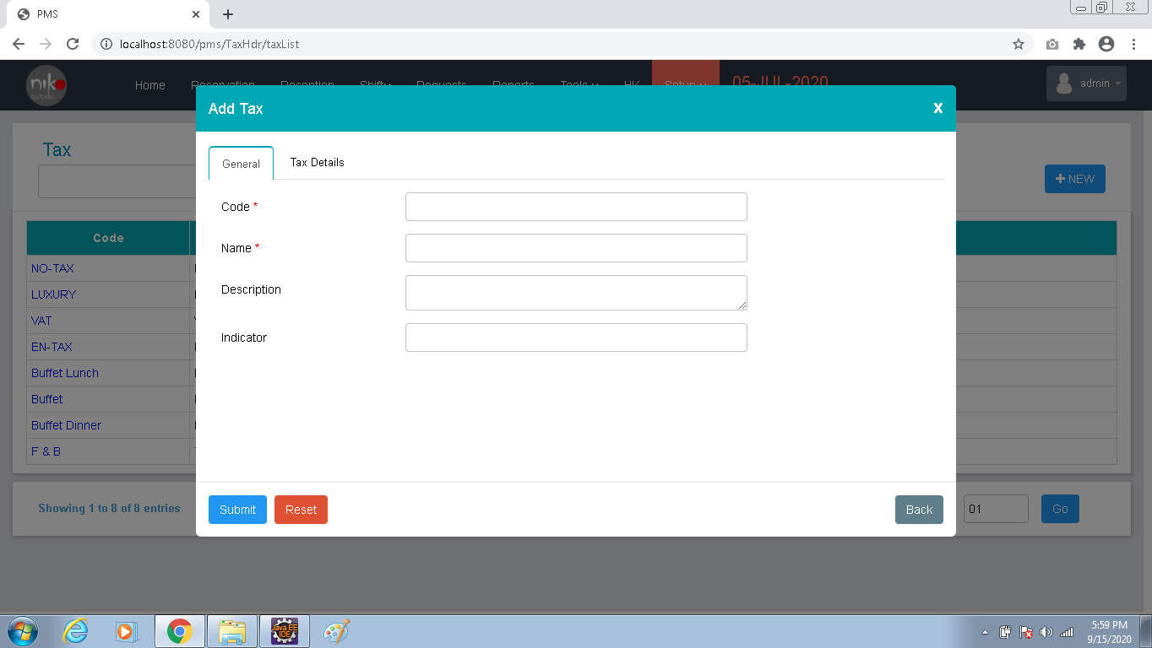

Fig: 10.7.3

|  |  |  |
| --- | --- | --- |
| Sl. No. | Contents | Description |
| 1 | Code | Enter the unique code |
| 2 | Name | Enter the name |
| 3 | Description | Add the description |
| 4 | Indicator | Add the indicator |

Table : 10.7.1

Add the tax details in the next section and click the submit button to add the new entry.

1. Shifts

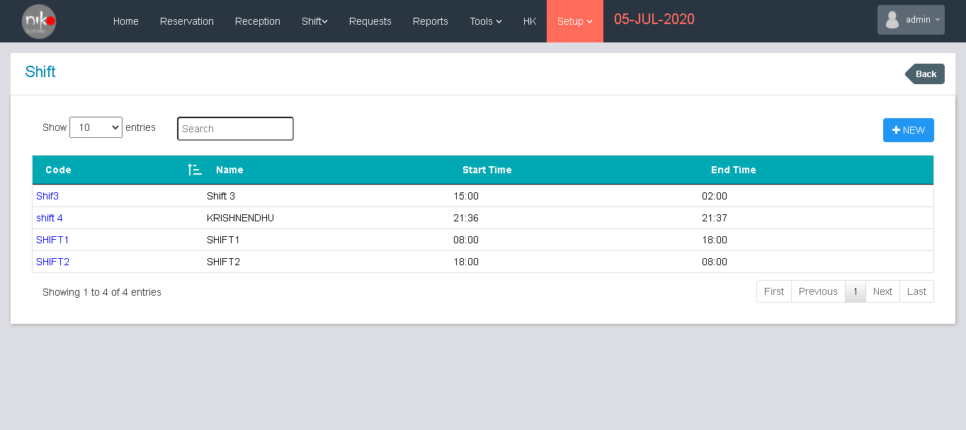

Fig:10.8.1

Here user can add, edit and view the details of shifts in the hotel. User can edit the shift details by clicking the item from the list and popup the edit window as shown below.

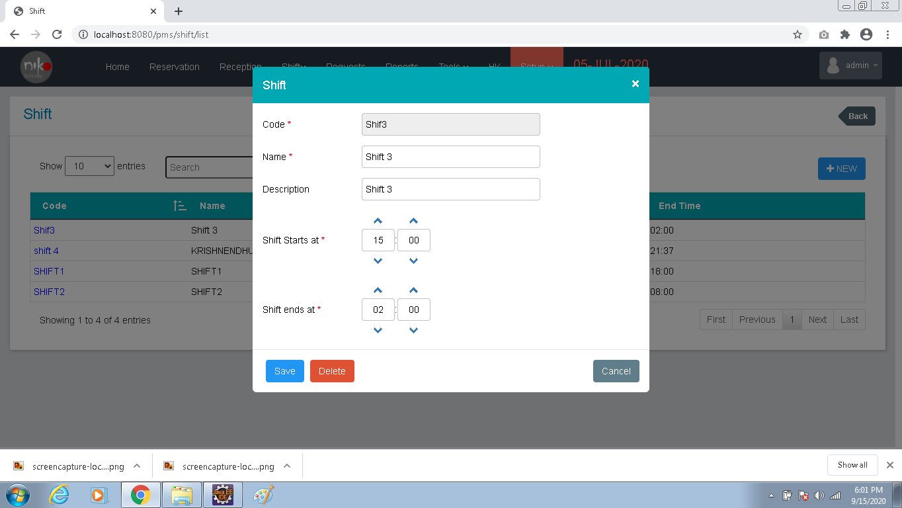

Fig: 10.8.2

User can change the shift details as per the needs and click the save button to make the change. User can add the new shift details by clicking the new button. Popup a new window for add a new entry as shown below.

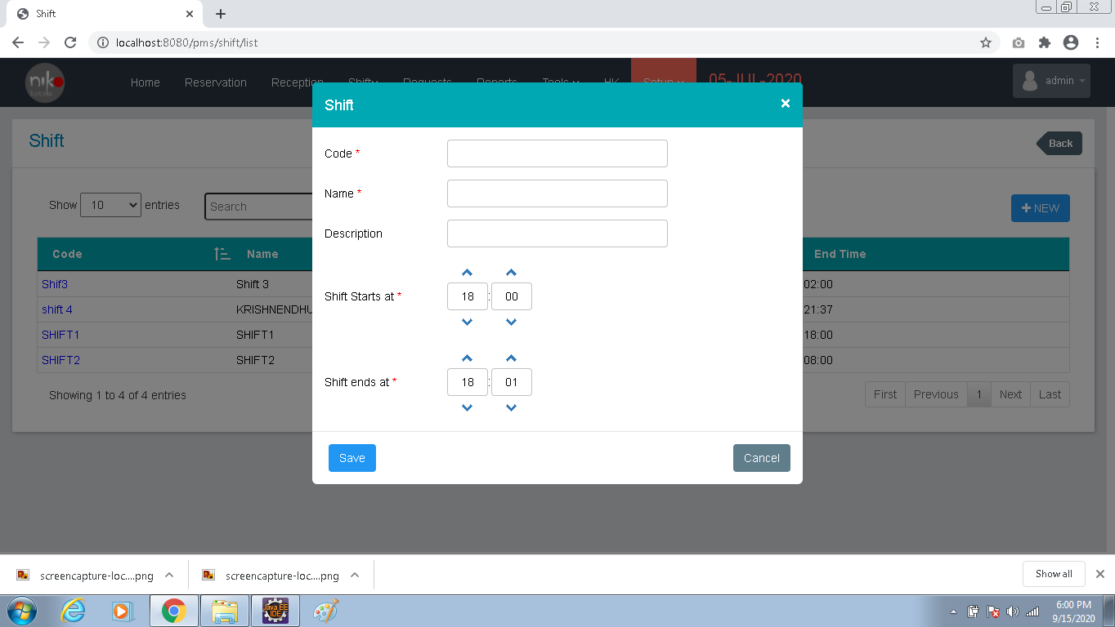

Fig: 10.8.3

|  |  |  |
| --- | --- | --- |
| Sl. No. | Contents | Description |
| 1 | Code | Enter the unique code |
| 2 | Name | Enter the name |
| 3 | Description | Add the description |
| 4 | Shift start at | Select the start time |
| 5 | Shift ends at | Select the end time |

Table: 10.8.1

Add the details as per the details given above and click the save button to add the new entry.

1. Room type

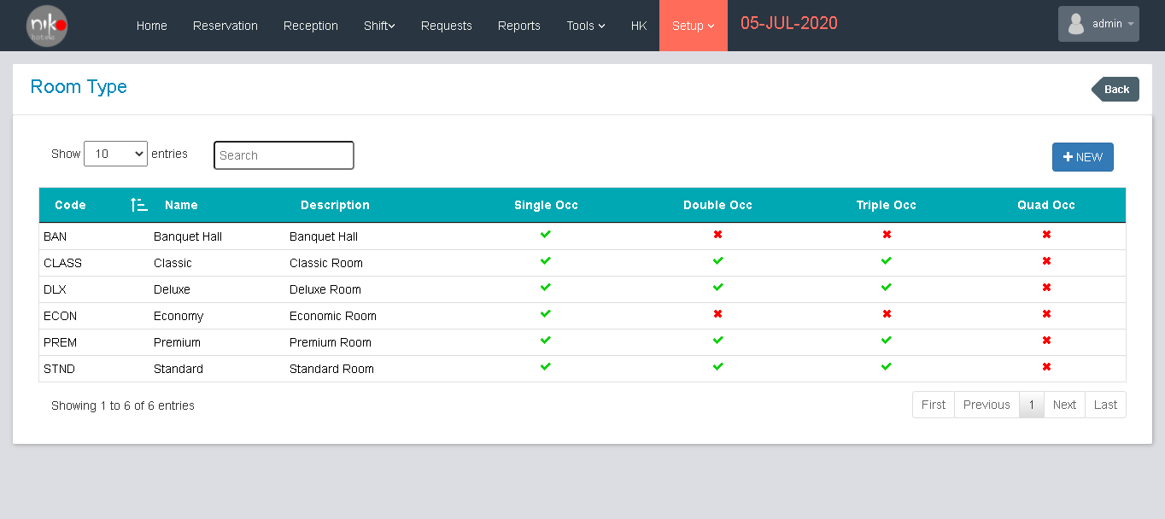

Fig: 10.9.1

User can add and view the room type details in this screen. User can add the new entry by clicking the new button shown in the screen. Then popup a new window to add the new entry as shown below.

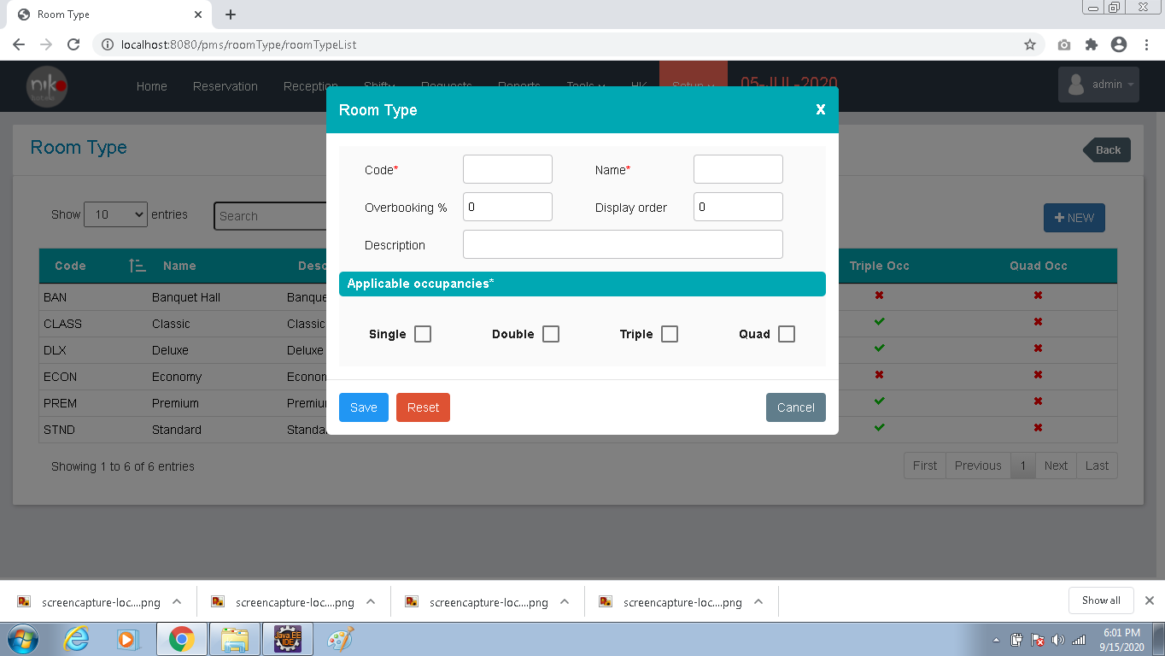

Fig:10.9.2

|  |  |  |
| --- | --- | --- |
| Sl. No. | Contents | Description |
| 1 | Code | Enter the unique code |
| 2 | Name | Enter the name |
| 3 | Overbooking % | Add the percentage of overbooking |
| 4 | Display order | Add the display order |
| 5 | Description | Add the description |

Table: 10.9.1

Then enable the applicable occupancies if needed.

1. Rooms

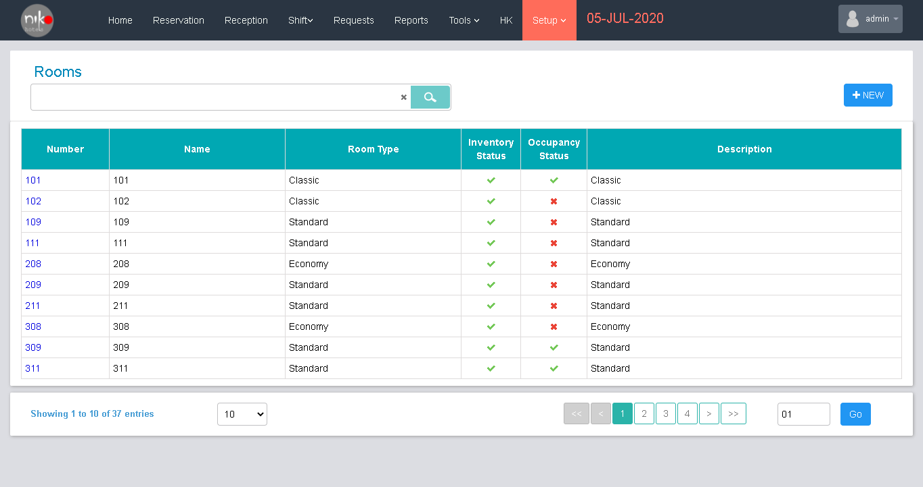

Fig: 10.10.1

Here user can add, edit and view the room list. User can edit the entry by selecting the entry from the list and popup an edit window as shown below.

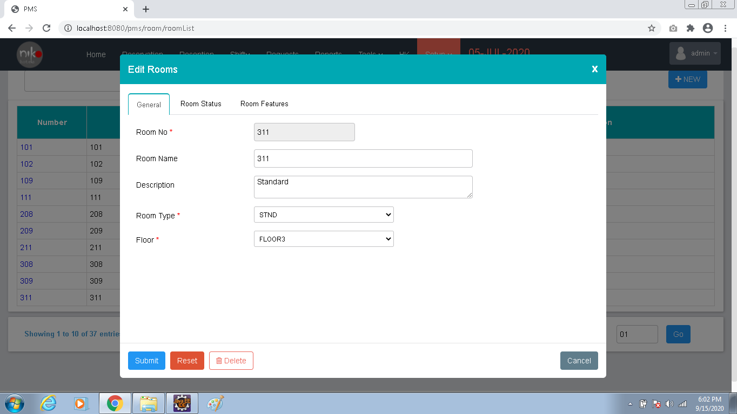

Fig: 10.10.2

User can change the details as per the changes needed and click the submit button to make the change. User can also delete the entry by clicking the delete button.

User can add a new entry by clicking the new button shown in the view page. When user clicks the new button, popup a new window for adding a new entry.

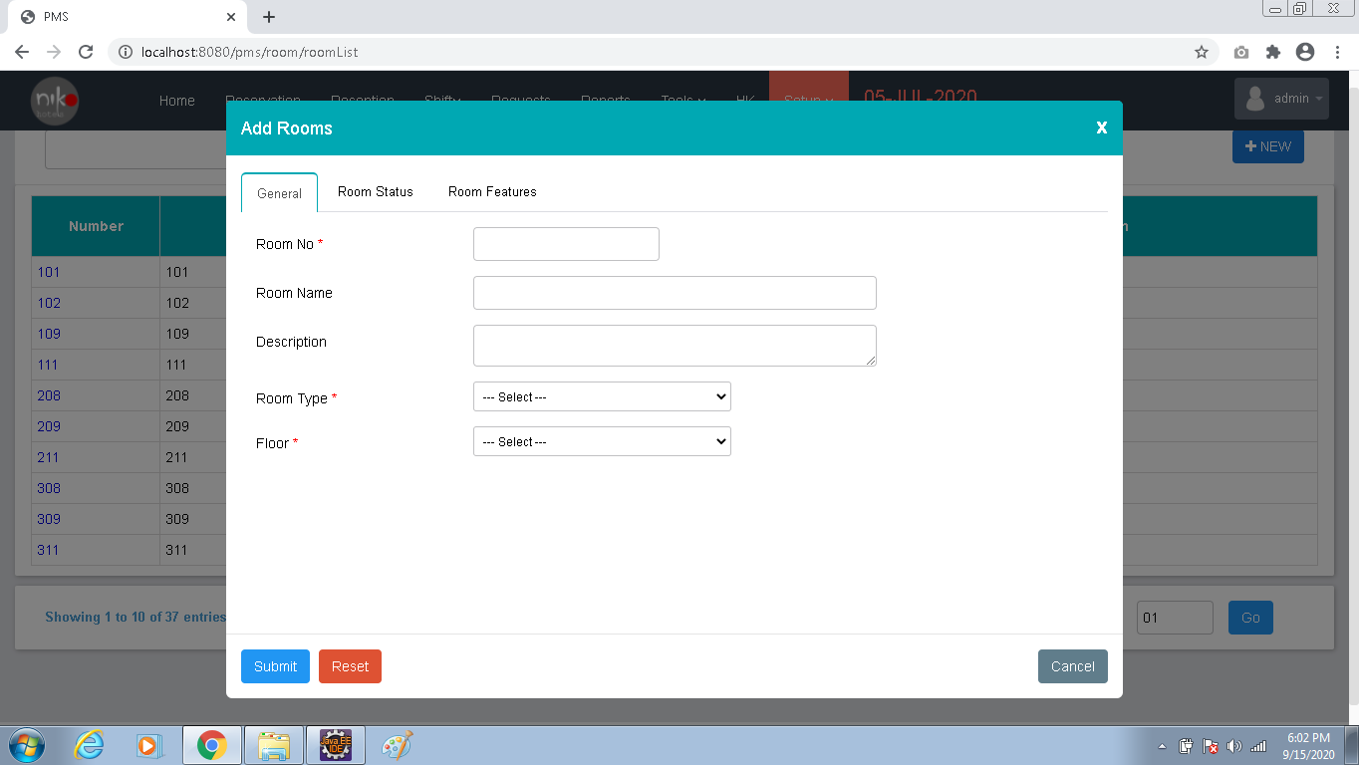

Fig: 10.10.3

|  |  |  |
| --- | --- | --- |
| Sl. No. | Contents | Description |
| 1 | Room No. | Enter the unique code |
| 2 | Room Name | Enter the room name |
| 3 | Description | Add the description |
| 4 | Room type | Select the room type from the dropdown |
| 5 | Floor | Select the floor from the dropdown |
| 6 | Inventory status | Change the inventory status if needed |
| 7 | House-keeping status | No need to change |
| 8 | Occupancy status | No need to change |

Table: 10.10.1

Add the proper details and click the submit button to add the new entry.

1. Floor

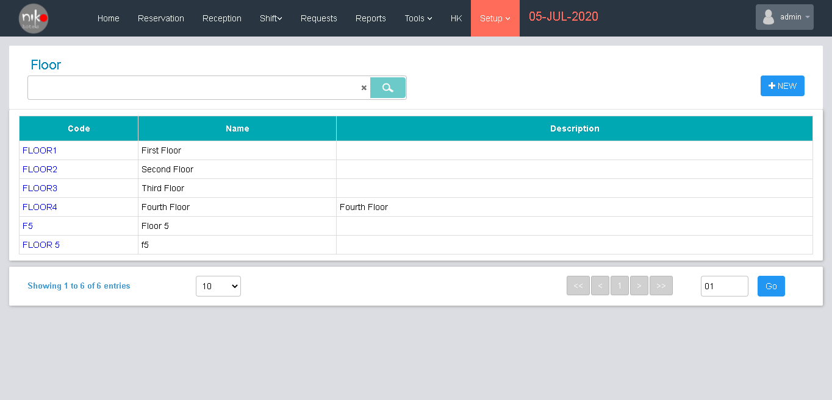

Fig: 10.11.1

User can add, edit and view the details of floors in the hotel in this section. User can edit the entry by clicking the entry from the list and popup a window for edit the entry as shown below.

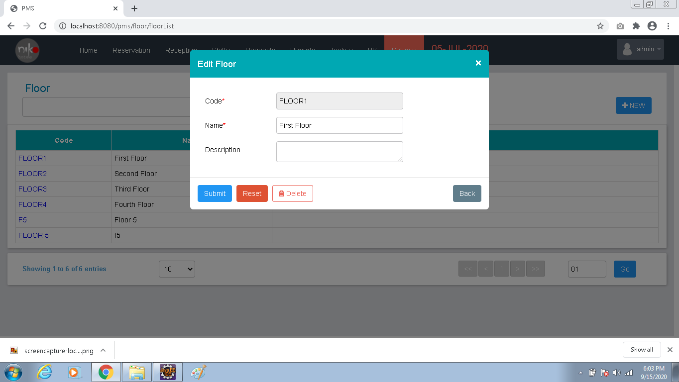

Fig: 10.11.2

User can make the changes if needed and click the submit button. User can also delete the entry by clicking the delete button shown in the window. User can add a new entry by clicking the new button shown in the view page and popup a new button as shown below.

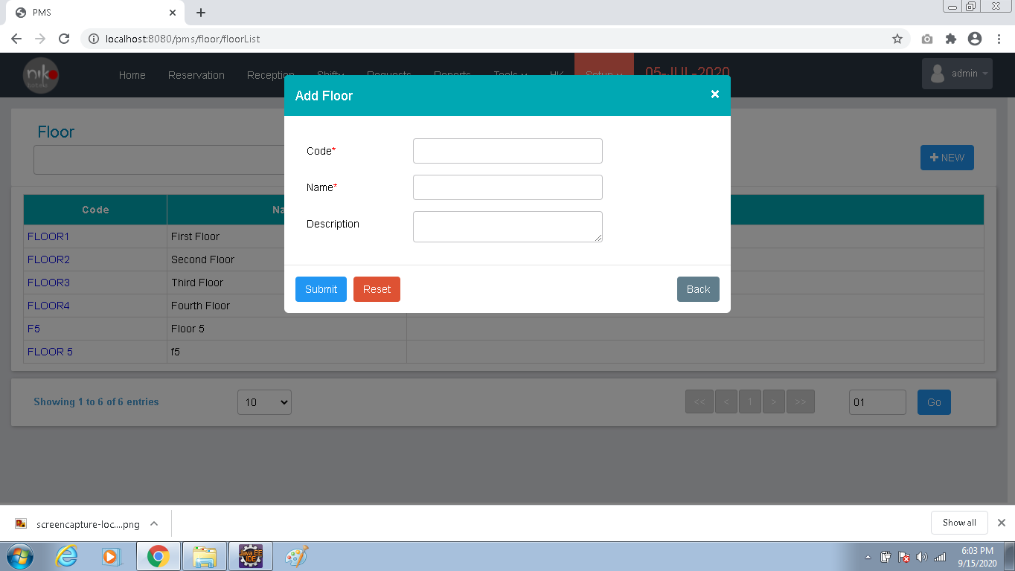

Fig: 10.11.3

|  |  |  |
| --- | --- | --- |
| Sl. No. | Contents | Description |
| 1 | Code | Enter the unique code |
| 2 | Name | Enter the floor name |
| 3 | Description | Add the description |

Table: 10.11.1

Add the details as per the details shown in the table and click the submit button to save the data.

1. Corporate ta rates

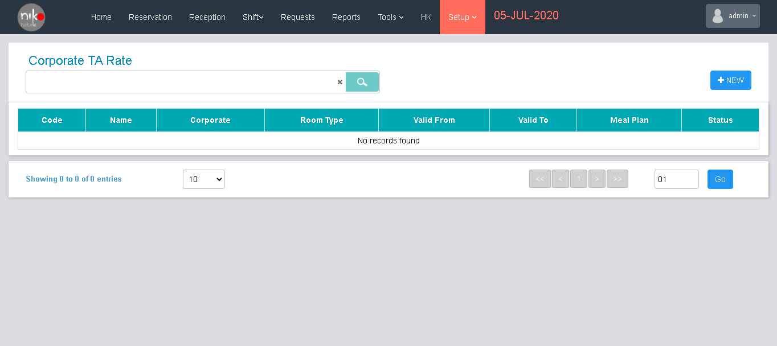

Fig: 10.12.1

User can add, edit and view the details of the corporate ta rate in the section. User can add a new entry by clicking the new button seen in the screen, then popup a new window for adding the new entry as shown below.

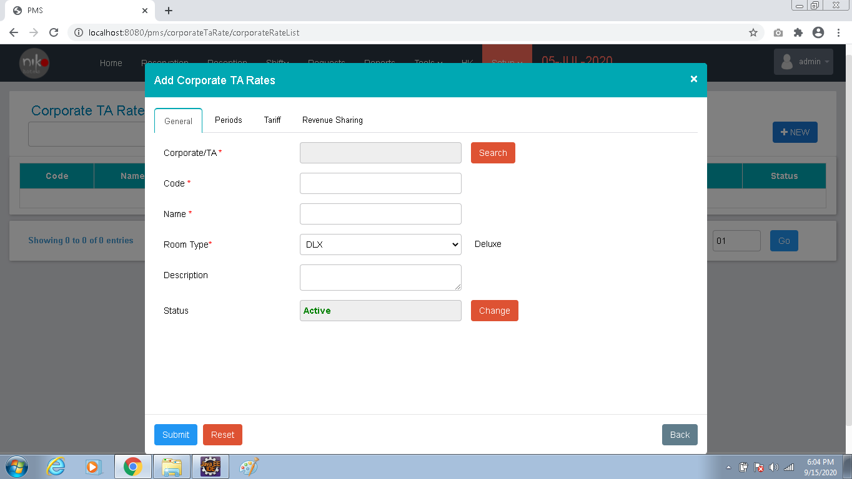

Fig:10.12.2

|  |  |  |
| --- | --- | --- |
| Sl. No. | Contents | Description |
| 1 | Corporate/TA | Select the item from dropdown |
| 2 | Code | Enter the unique code |
| 3 | Name | Enter the name |
| 4 | Room type | Select the room type from the dropdown |
| 5 | Description | Add the description |
| 6 | Status | Change the status if needed |
| 7 | Agreement ref. | Enter the agreement reference number |
| 8 | From | Select the from date |
| 9 | To | Select the to date |
| 10 | Traffic include the taxes | If taxes included enable the checkbox |

Table: 10.12.1

Then add the details of meals plan, traffic and revenue sharing then click the submit button to add the new entry.

1. Room rate

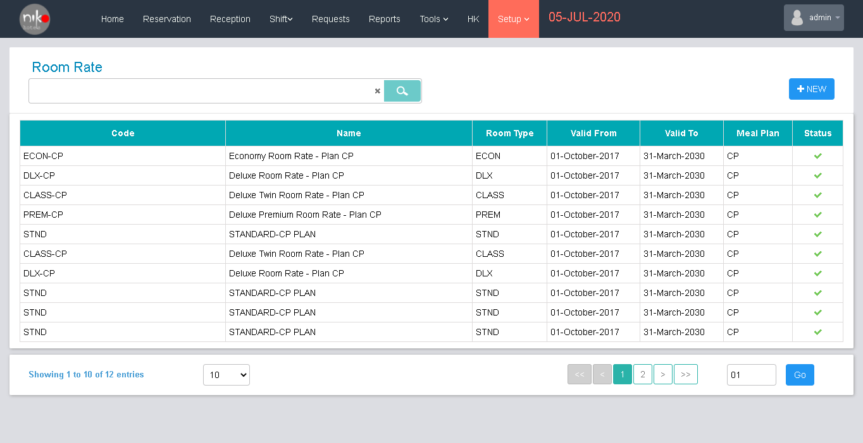

Fig: 10.13.1

User can add and view the details of room rates available in the hotel. User can add the new rate details by clicking the new button shown in the screen, then popup a new window as shown below for add a new entry.

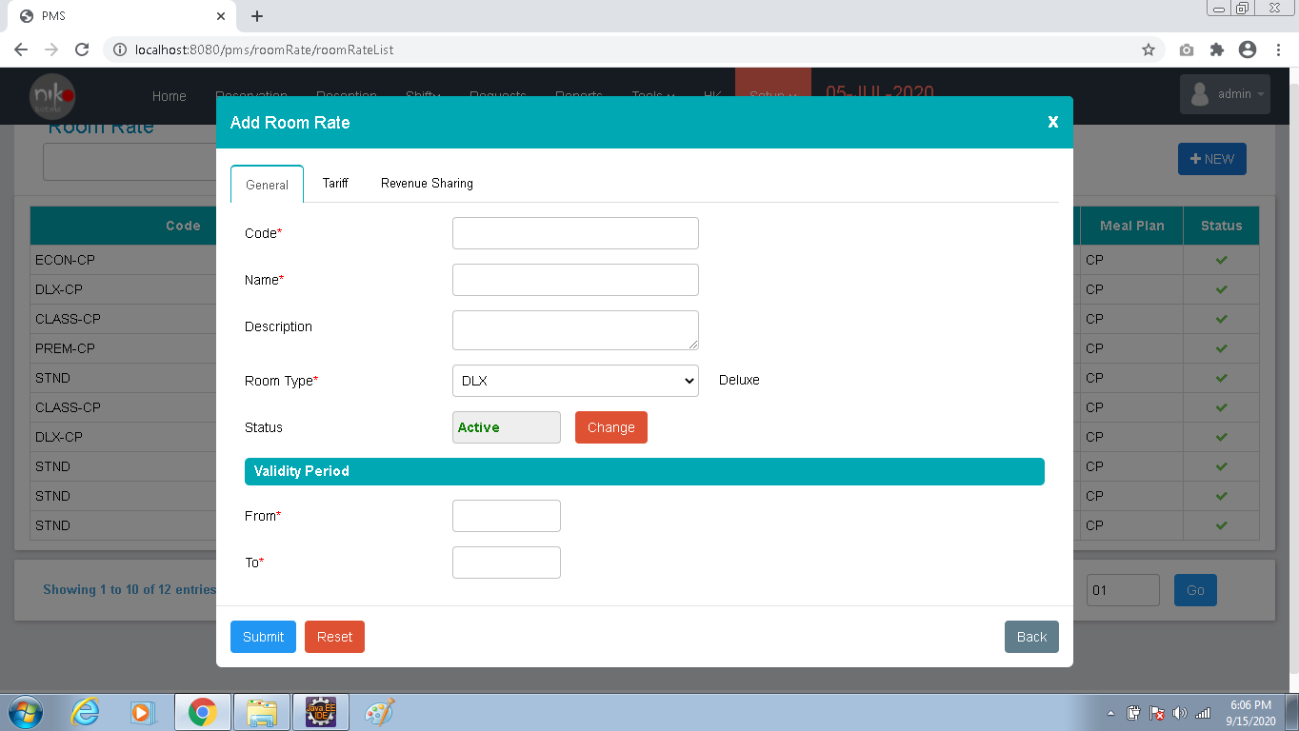

Fig: 10.13.2

|  |  |  |
| --- | --- | --- |
| Sl. No. | Contents | Description |
| 1 | Code | Enter the code |
| 2 | Name | Enter the name |
| 3 | Description | Add the description |
| 4 | Room type | Select the room type from the dropdown |
| 5 | Status | Add the description |
| 6 | From | Select the from date |
| 7 | To | Select the to date |
| 8 | Traffic include the taxes | If taxes included enable the checkbox |

Table: 10.13.1

Add details as per the table and click the submit button.

1. Corporate

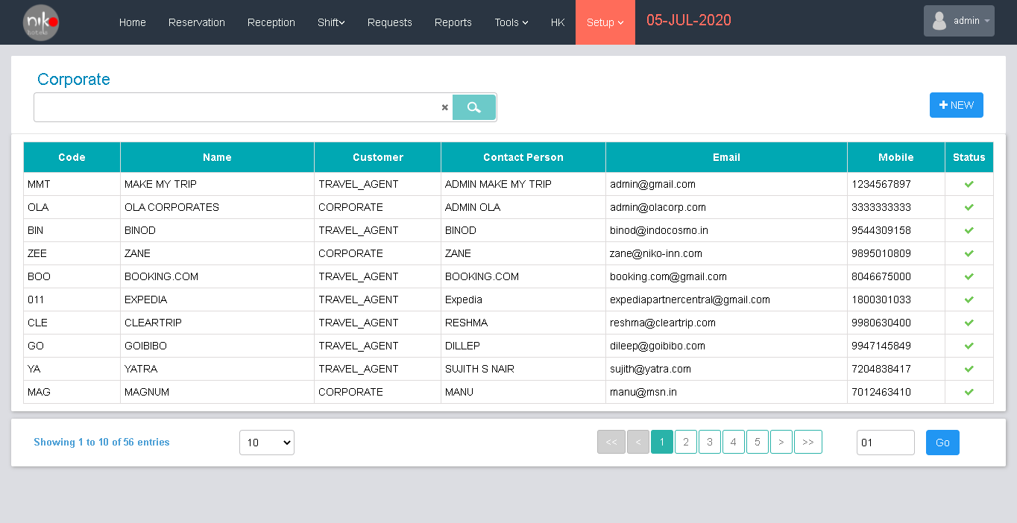

Fig: 10.14.1

User can add and view the corporate details from this section. User can add a new entry by clicking the new button shown in the screen then popup a new window for add entry as shown below.

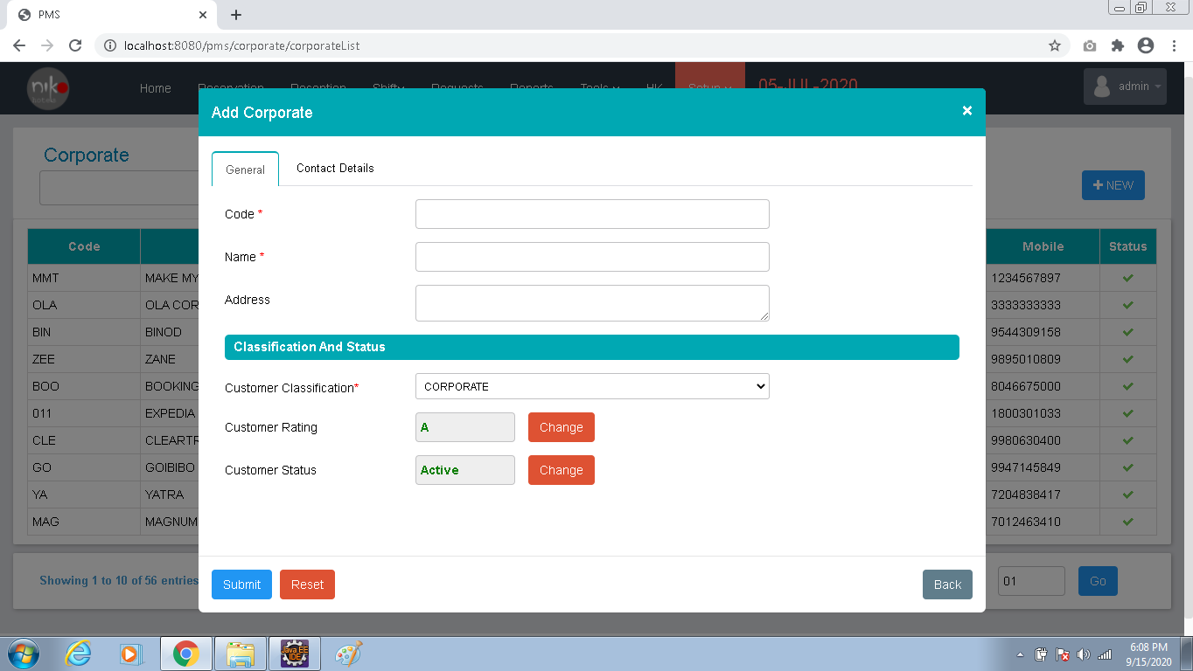

Fig: 10.14.2

|  |  |  |
| --- | --- | --- |
| Sl. No. | Contents | Description |
| 1 | Code | Enter the unique code |
| 2 | Name | Enter the name |
| 3 | Address | Add the address |
| 4 | Customer classification | Select the item from the dropdown |
| 5 | Customer rating | Change the rating if needed |
| 6 | Customer status | Change the status if needed |
| 7 | Contact person | Enter the name of contact person |
| 8 | Email address | Enter the email id |
| 9 | Mobile number | Enter the mobile number |
| 10 | Office phone | Enter the office phone number |
| 11 | Fax | Enter the fax number |
| 12 | Back office account no. | Enter the account details |

Table: 10.14.1

Add the details as per the table shown above and click the submit button to save the data.

# How to Install